

**Final Report of Game ‘ Must Kill ’**

**SOFTWARE PROJECT MANAGEMENT**

D2

Wen Haoyu

Huang Yixing

Zhang Haozhan

Sun Yiran

A report submitted to fulfil requirements for Course CS252

# Table of Contents

Table of Contents II

Chapter 1 Requirement Analysis 1

1.1 Background 1

1.2 Problem 1

1.3 Functional Requirements 2

1.4 Non-Functional Requirements 3

1.5 User-case Diagram 3

Chapter 2 Software Design 5

2.1 Software Process Model 5

2.2 Design Methodology 7

2.3 Component 8

2.4 Class-Diagram 15

Chapter 3 Agile Development 16

3.1 Team Structure 16

3.2 Overview 16

3.3 Product Roadmap 16

3.4 Milestone 17

3.4.1 Backlog 1 17

3.4.2 Backlog 2 17

3.4.3 Backlog 3 18

3.4.4 Backlog 4 18

3.5 Defect Record 19

3.6 Sprint 19

3.6.1 Sprint 1 （2.7-2.25） 19

3.6.2 Sprint 2 （2.26-3.13） 20

3.6.3 Sprint 3 （3.13-4.13） 20

3.6.4 Sprint 4 （3.13-4.13） 21

3.7 Sprint Review 21

Chapter 4 Budget and Schedule 22

4.1 human resources cost 22

4.2 development tools and software cost 22

4.3 hardware resource 23

4.4 other 23

4.5 schedule milestone week 1-2 23

4.6 schedule milestone week 3-4 23

4.7 schedule milestone week 5-11 23

4.8 schedule milestone week 12 23

Chapter 5 chapter 5 software metrics and equations 25

5.1 feasibility check 25

5.2 software size estimation（LOC） 25

5.3 resource estimation（use case + decomposition） 26

5.4 metrics of process and projects 26

5.5 function point calculation（non adjusted） 26

5.6 function point calculation（adjusted） 27

5.7 use-case oriented metrics 27

5.7 DRE 27

Chapter 6 Tracking and Control 29

6.1 EVA 29

6.1.1 Sprint 1 29

6.1.2 Sprint 2 29

6.1.3 Sprint 3 29

6.1.4 Sprint 4 30

6.2 Control 30

6.2.1 Scope Validation 30

6.2.2 Scope Control 30

Chapter 7 Risk Management 31

7.1 Visualization Static Interface ( 3‘M’) 31

7.2 Database Structure 32

7.3 Pareto 80-20 rule 32

Chapter 8 Software Quality Assurance 33

8.1 Functional and performance requirements 33

8.1.1 Functional requirements: 33

8.1.2 Performance requirements: 33

8.2 Documentation of development standards 33

8.3 Implicit characteristics needed 34

8.4 FTR 34

8.4.1 Membership 34

8.4.2 Overview 34

8.4.3 Advanced Preparation 35

8.4.4 Inspection Meeting 36

8.4.5 Rework 37

8.4.6 Follow up 38

Chapter 9 Software Project Management 39

9.1 Software Reliability 39

9.2 Software Safety 40

9.3 Quality Standard 40

9.4 CMM Model 41

9.5 SCM 42

9.6 Version Control 45

Chapter 10 Software Team Organization and Teams 47

10.1 Team structure 47

10.2 Personality test 47

10.3 Contribution-based evaluation 47

Chapter 11 Course Reflection, Practices, and Comments 49

11.1 Wen Haoyu (Project Manager) 49

11.2 Zhang Haozhan (Copywriting team) 50

11.3 Sun Yiran (Copywriting team) 50

11.4 Huang Yixing (Code writing team) 51

# Requirement Analysis

## Background

As an old card game that was once all the rage, Three Kingdoms Kill has a decreasing audience due to the gradual aging and niche of the main user group, coupled with the unreasonable balance of game planning, and at the same time, as a casual card game, its clumsy hosting function cannot free users' hands. In order to increase the attractiveness of the game to young users and improve the user experience, based on the original Three Kingdoms Killing mechanism, we also need a younger product, which we call MUST Killing.

## Problem

We divide our problems into two aspects:

* Technical Aspects:

1. In the context of a game based on the Three Kingdoms, how can MUST elements be skillfully integrated into the game without losing the original characteristics of the game? For example, corresponding the teacher's traits to appropriate martial arts roles, as well as rationally replacing skill tiles with MUST elements that have the same meaning, are all worth considering.
2. Since we were creating a “game project” as a formal team for the first time in college, the choice of technology stack, such as Unity, was also a big issue.
3. We are also going to design the AI hosting system, and the calls to the api as well as stability need to be reconsidered.

* Team Aspects:

1. In terms of group division of labor, we need to select a project manager who needs to regulate the operation of the whole team. How to find out this person who can connect and manage the whole team is the key.
2. With each team member living in a different location, it was a question of how we could function with the limitations of online meetings to communicate more efficiently.
3. In project development, faced with multiple tasks coming one after another, how to reasonably plan time and dynamically assign priorities according to task attributes is a difficult task.

## Functional Requirements

* 1v1 vs AI Mode
* The rules of the game follow those of “Three Kingdoms”, but with elements of the Macau University of Science and Technology.
* There are a variety of cards in the game, (e.g., basic cards, equipment cards, and skill cards) each of which has a different effect, and the player can choose to play a card each turn to achieve a certain effect.
* The game should provide real-time feedback showing the game status of both players, card usage, and the course of the battle (e.g., if I use “kill” on my opponent, my hand is reduced by one card, and my opponent should be deducted one drop of blood).
* The game needs to have a BGM to keep the player immersed.

## Non-Functional Requirements

* The game shall support 1v1 real-time battles, ensuring a smooth experience with a latency of no more than 100ms.
* The loading time of the game should be as short as possible and should not take more than 5 seconds to enter the game.
* The game interface needs to be simple and easy to navigate to ensure that the player can quickly understand and get started.
* After the match, the player's historical data shall be archived and supported for viewing at any time.

## User-case Diagram

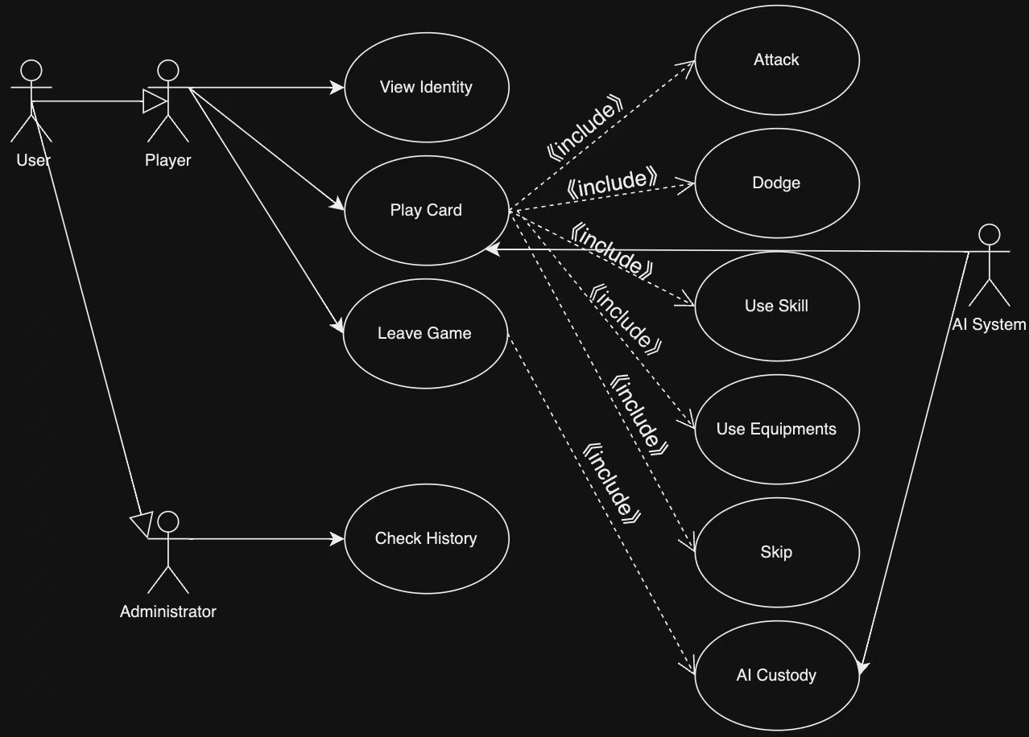

Figure1 User-case Diagram

As shown in the figure, in addition to displaying the game functionality, the User-case Diagram shows a complete scenario of the Actor interacting with “MUST Killing”.

At a macro level, the Actor of the game is divided into the User, who plays the game, and the Administrator, who manages the game, and whose only job is to check the history of the game. The only thing the Administrator can do is check the history of the game, while the Player can do a lot of things, such as choosing the identity of the hero, playing cards, and leaving the game. The “big action” of playing a card can be extended to a number of secondary actions, such as attacking an enemy, dodging an enemy's attack, using a skill, using a piece of equipment, or skipping this part of the game during the card playing phase.

When you leave the game, you will automatically start the next game after entering the settlement interface and get a new hand.

# Software Design

## Software Process Model

For our “MUST Killing” game project, we used **Leangoo**, which was recommended by our teacher, as our model for the software development process.

Leagnoo is an iterative development methodology that emphasizes the gradual refinement and improvement of a product through multiple small iteration cycles. In each iteration cycle, our team conducts requirements analysis, design, development, and testing to ensure that the functionality and quality of the software can be progressively improved.

Below is an overview of our leagnoo model: we have 4 sprints with a Sprint Review at the end and each sprint ends with a milestone, a representation of the defects in the tasks, and a complete product roadmap that gives a chronological overview of our work.

A Sprint usually refers to a fixed, shorter development cycle, usually 1 to 2 weeks. In each Sprint, the team focuses on specific tasks and functional modules. The goal of each Sprint is to progressively advance the development and refinement of the product through rapid iteration and frequent feedback. Planning Sprints helps our team to deliver work efficiently in a short period of time and to adapt quickly to changes in requirements.

Also, Sprint Review are very important. It allows us to revisit the path we've traveled after a Sprint is over. Through retrospectives, we can reflect on the weaknesses, build on the strengths, and work better in the next Sprint.

Milestones are important points in the project. With it, we can clearly recognize the progress and results of the project. It also helps us to instantly find out the important features that are not yet done. Milestones can't be established, planned and completed without the team's communication, which also makes our team closer. Finally, watching the Milestones being completed one by one gives us a sense of accomplishment. It is a great morale booster!

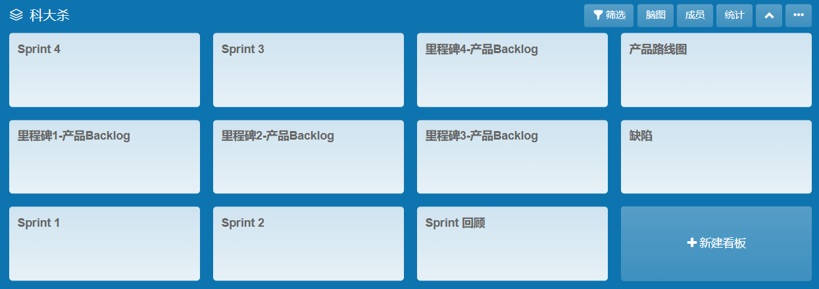

Look at a Sprint specifically: We have collected a number of “User Stories”, which are an approach to describing requirements from the user's perspective, emphasizing the needs of the end-user, and helping the team understand the user's goals and expectations.It's very simple language and very vernacular, conveying just the user's wishes. For example, “I want killer teachers to be in character” is a very simple user request that we need to turn into a specialized task.

Specialized task is also shown in the board. First of all, for this simple request, we split it into the first priority task of “Ask for a killer list”. When we finish the first task, we understand the scope of the “Killer” group as described by the user. Then we incorporated the facial features of the “Killer” into the original general's character to make it more immersive.

Finally on the board we will also show the defects and budget analysis for this phase, which will help us to do better in the next Sprint.

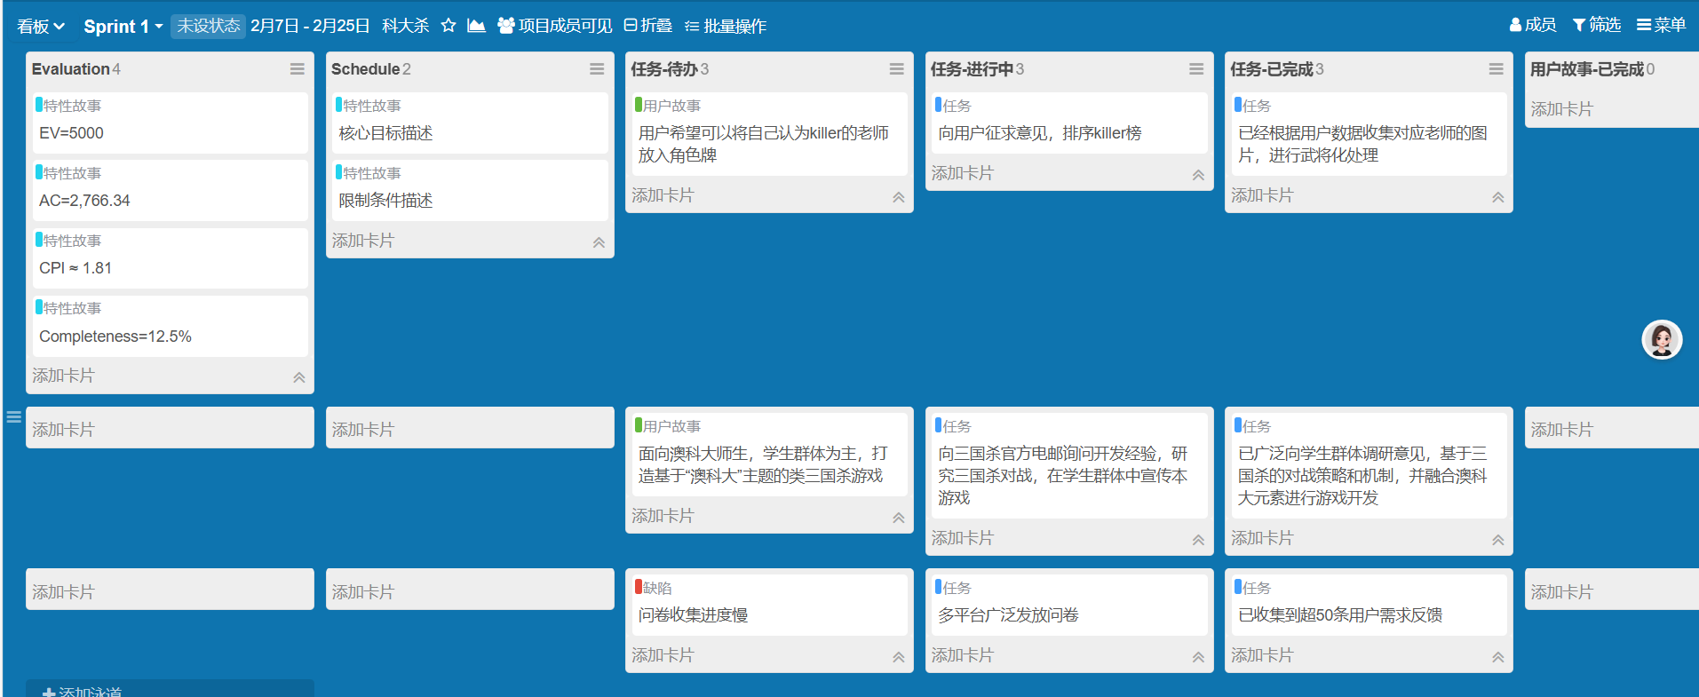

In Milestones, we show Epic Stories and User Story Pools. An epic story is a user story that is large, complex and usually takes a long time to complete. For example, inside this board, we identify the target audience and player needs. This User Story Pool integrates detailed versions of all Sprint1's user stories, meaning that every true statement of every player has been recorded by us. For example, this board shows the details of our questionnaire “User 1 thinks that Mr. XX's exams are too strict”.

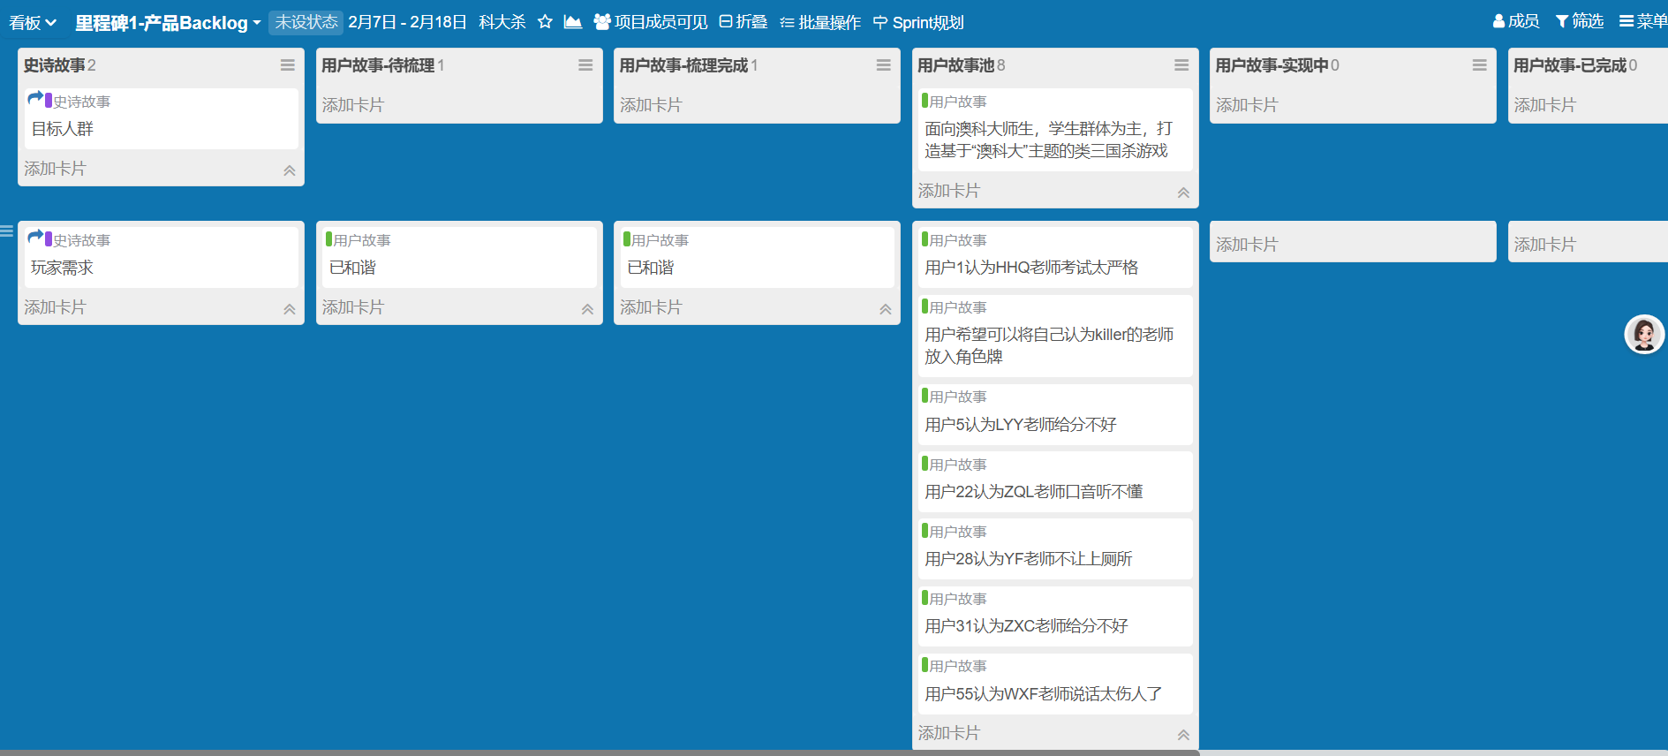

## Design Methodology

We adopted the **Scrum** framework for **Agile** development and the above leangoo used for the software, dividing the project into **4** Sprints. in each Sprint, we focus on developing and delivering a functional module or requirement. At the end of each iteration, the team conducts a retrospective, collects feedback, and adjusts the development plan and prioritization based on the results.

Our game engine of choice is the **Unity engine**. We are able to efficiently implement game features and quickly validate designs. We work closely with Unity's features during the design and development process, utilizing its powerful tools to accelerate the development process. For example, we rely on Unity's physics engine and animation system to provide strong support for the game's dynamic effects and interactions, helping us to realize a silky smooth combat system.

## Component

In this subsection, we will explain in detail each element inside our game entity.

When you click on our game, a MUST stadium is in the background with our own logo “MUST WAR” in the center. Our logo retains the character of the cold weapon in the context of the Three Kingdoms game, while highlighting the MUST.

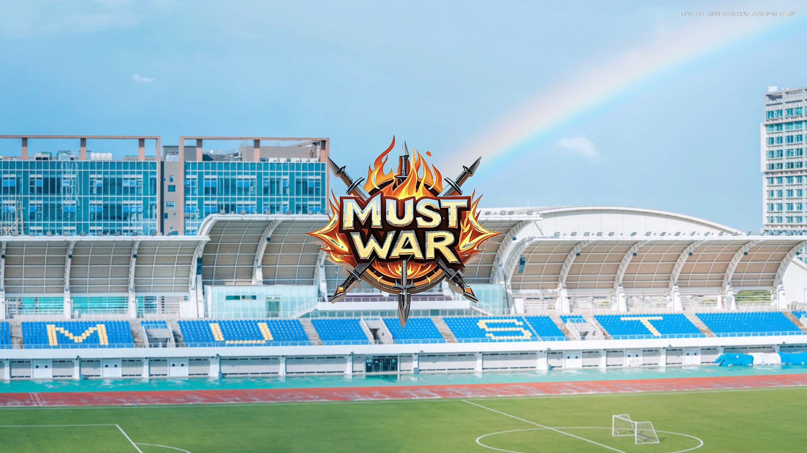

As we entered the game, we were greeted by the interior of MUST's O Block classroom. This beautiful sunset adds a bit of warmth to the whole tense and exciting game.



When the game ends, the interface presents a view of a MUST gate. This image not only represents the elements of MUST, but also the metaphor of “escaping” the school at the end of the game.



After introducing the background, the next step is the in-game UI design.

Entering the game, we can find a two-player versus mode. Each player has a certain amount of hand, and our hand is visible to us while the enemy's is not. At the same time, each player has an Equipment Area that belongs to ourselves, and from the pictures, it looks like we haven't equipped ourselves with weapons yet, while the enemy is already fully armed. Each player has an initial amount of blood, which we define as “GPA”. In this picture, the enemy's GPA is 3 and ours is 4. There are three buttons on the top of our hand, “Confirm Play”, “Cancel Play” and “Skip Play”.

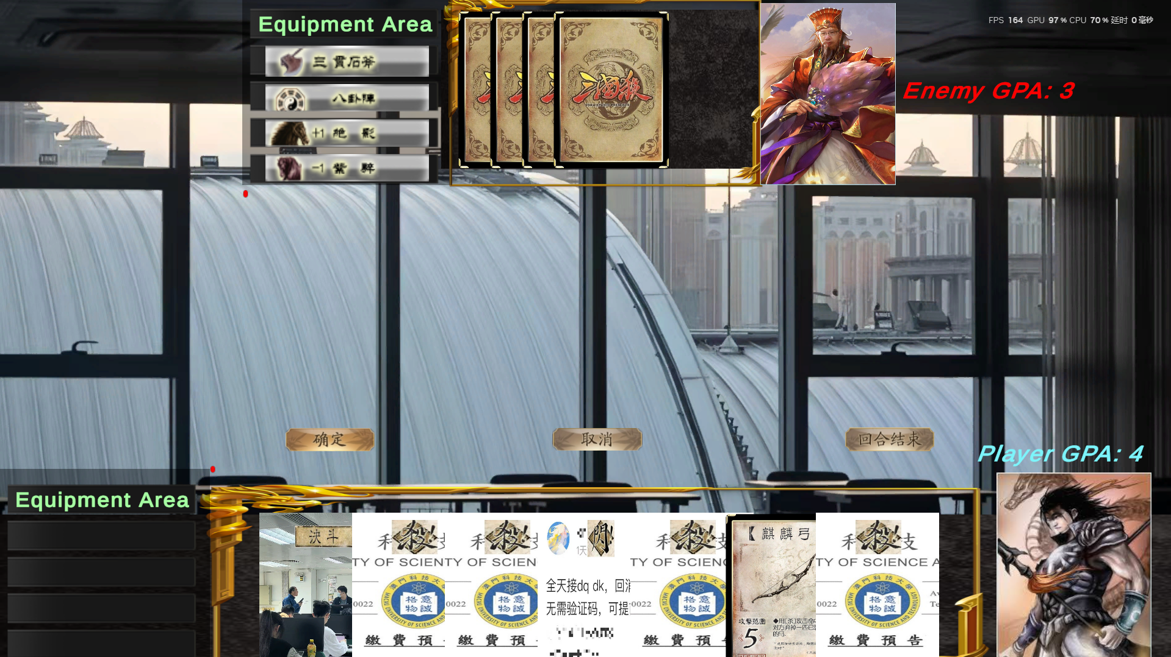

The next step is the introduction of subtle operations.

The first is the use of equipment cards. If we click on the equipment tile and then click Certain, the equipment name will automatically appear in our Equipment Area.

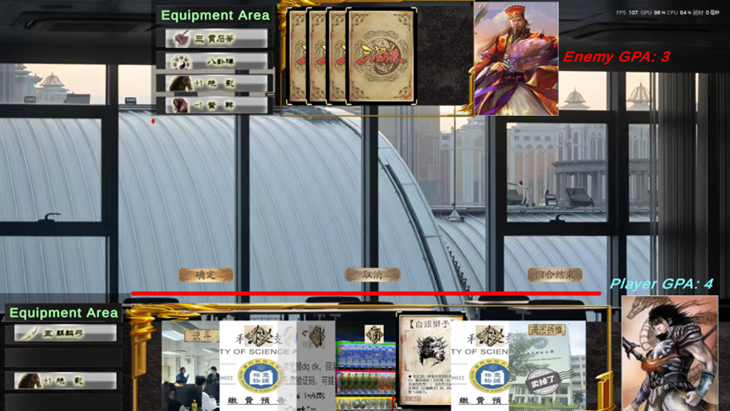

The picture below shows the use of skill cards, using “GUOHECHAIQIAO” as an example. When we play the “GUOHECHAIQIAO” card, an invisible deck will appear in the center of the screen, and we need to randomly choose a card to make our opponent lose a piece of equipment.

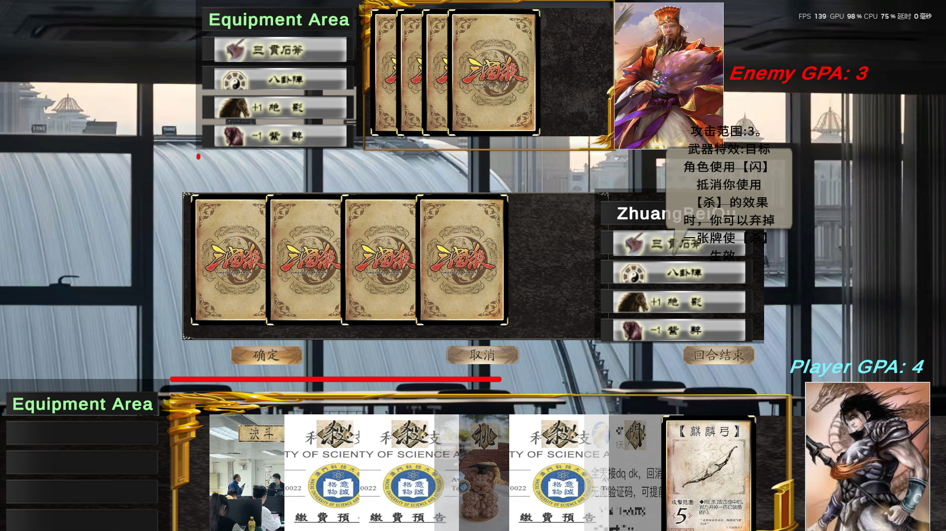

For new players, especially those who do not understand the rules of the game of Three Kingdoms at all, we have also set up a thoughtful tips for playing cards. When we hover the mouse over a card, the summary reproduces a piece of rule text that instructs the player how to go about playing the card.

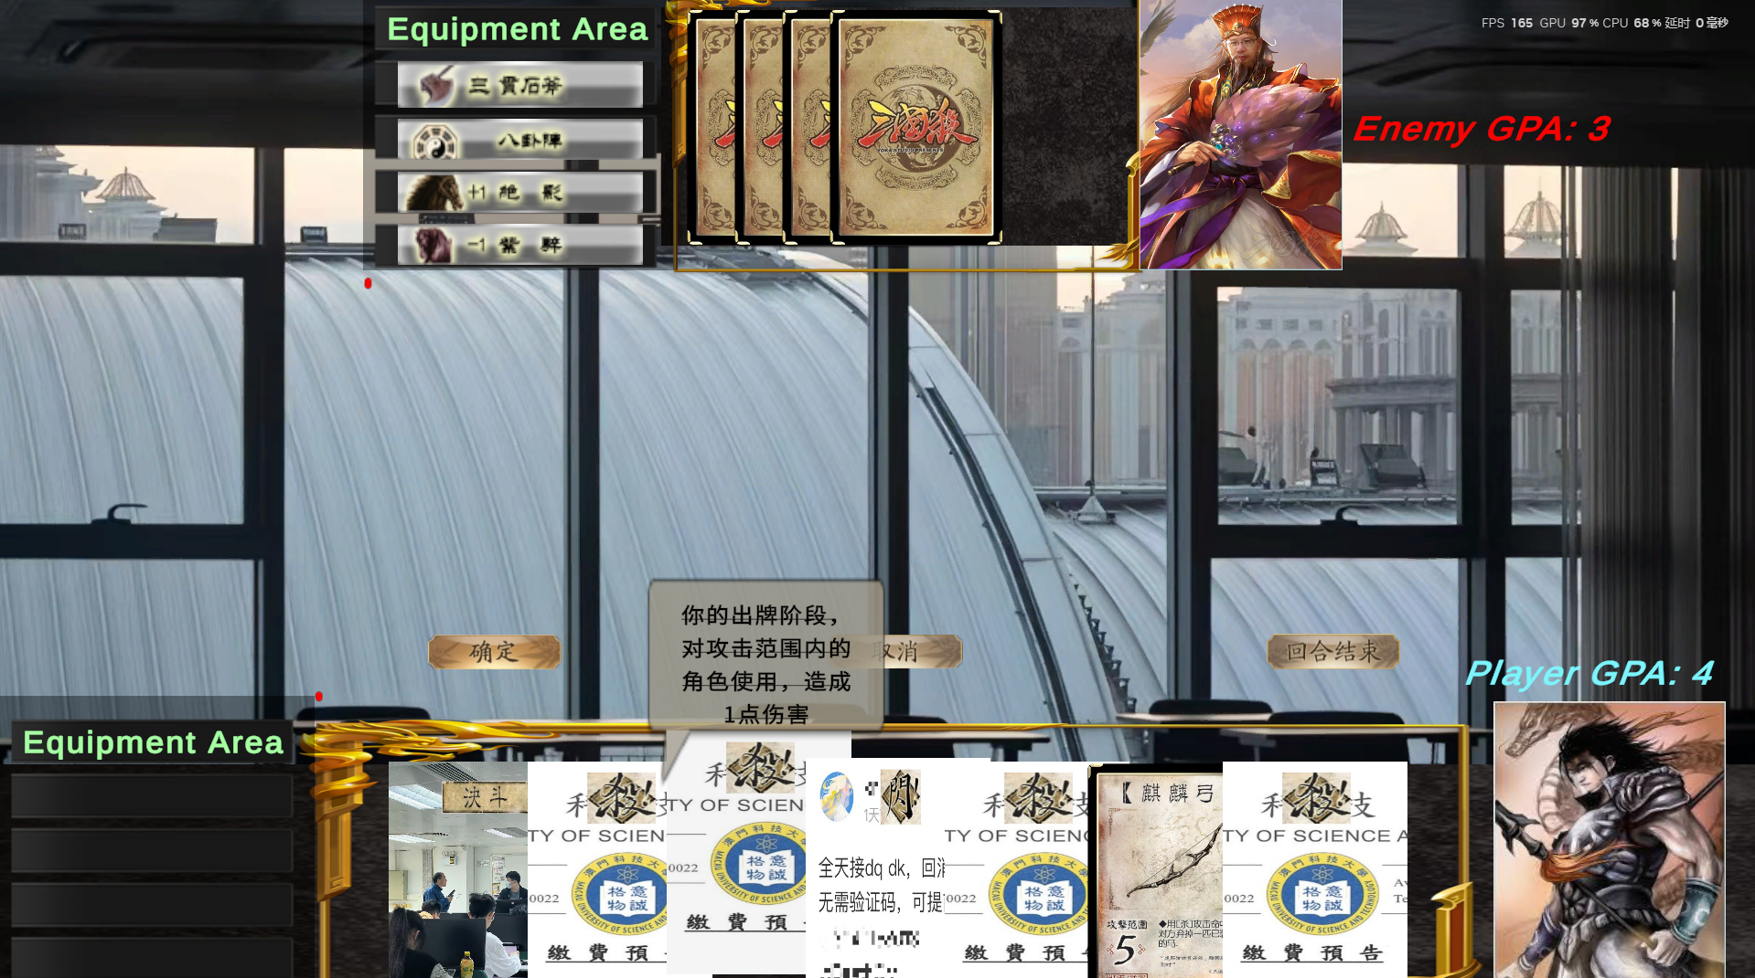

These are the basic gameplay of our game. In addition to the intense and exciting battles, our localized elements are also a major attraction for players.

For example, the skill “SHA” is killing people. We chose MUST's tuition payment teaser to describe the feeling of mental and physical pain.

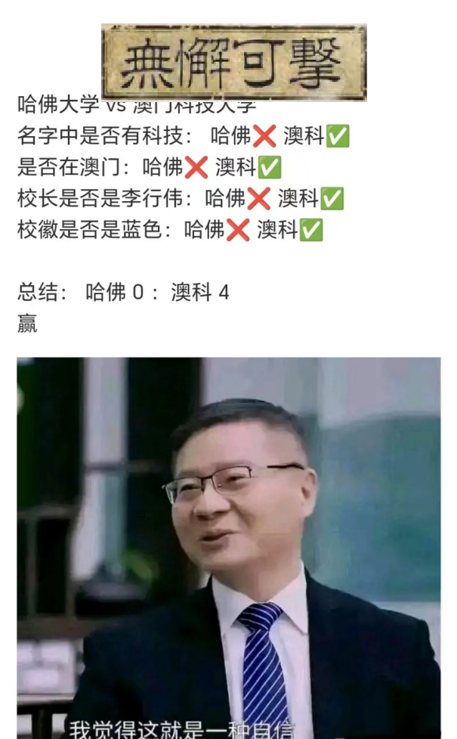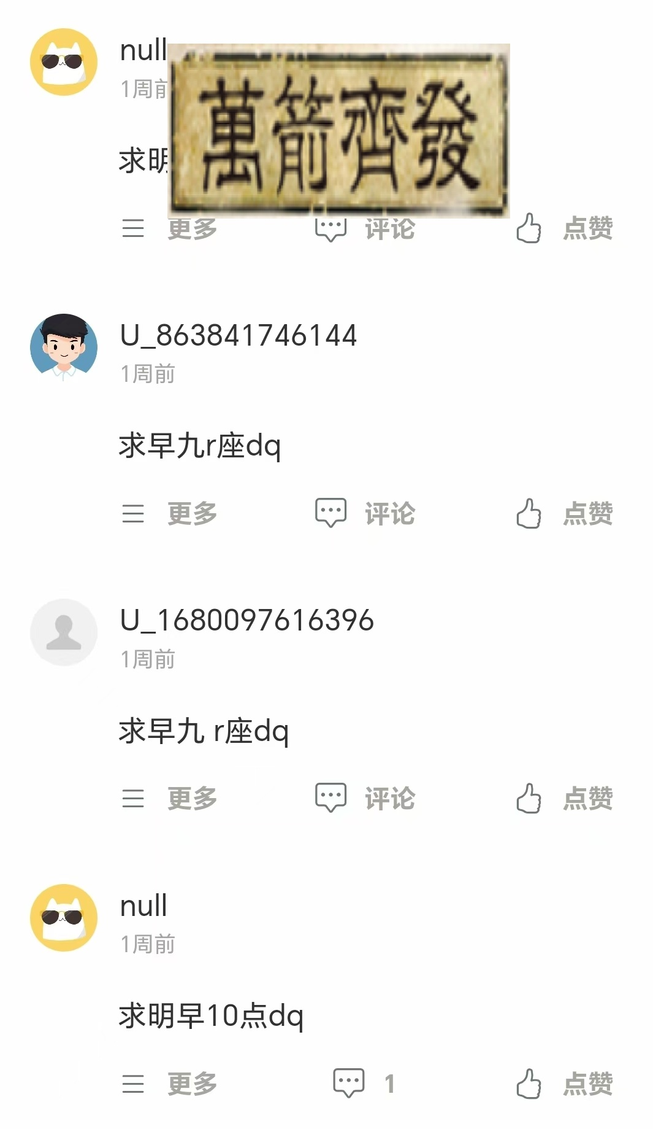

Secondly, the skill “WUZHONGSHENGYOU” means to create something out of nothing. We chose a college ranking about MUST to lend irony to the inauthenticity of XX rankings.

The third skill is “WUXIEKEJI”, which means invulnerable. We chose a chart where no matter how MUST and Harvard compare, we can find a way for MUST to win forever, and that's called “invulnerability.”

The fourth is “WANJIANQIFA”, which means “Ten Thousand Arrows”. The act of checking in for someone is common at the college level, and MUST is no exception. So whenever we open the tree hole, especially on days when there are a lot of early classes the next day, we find a lot of these comments comparable to a million arrows.

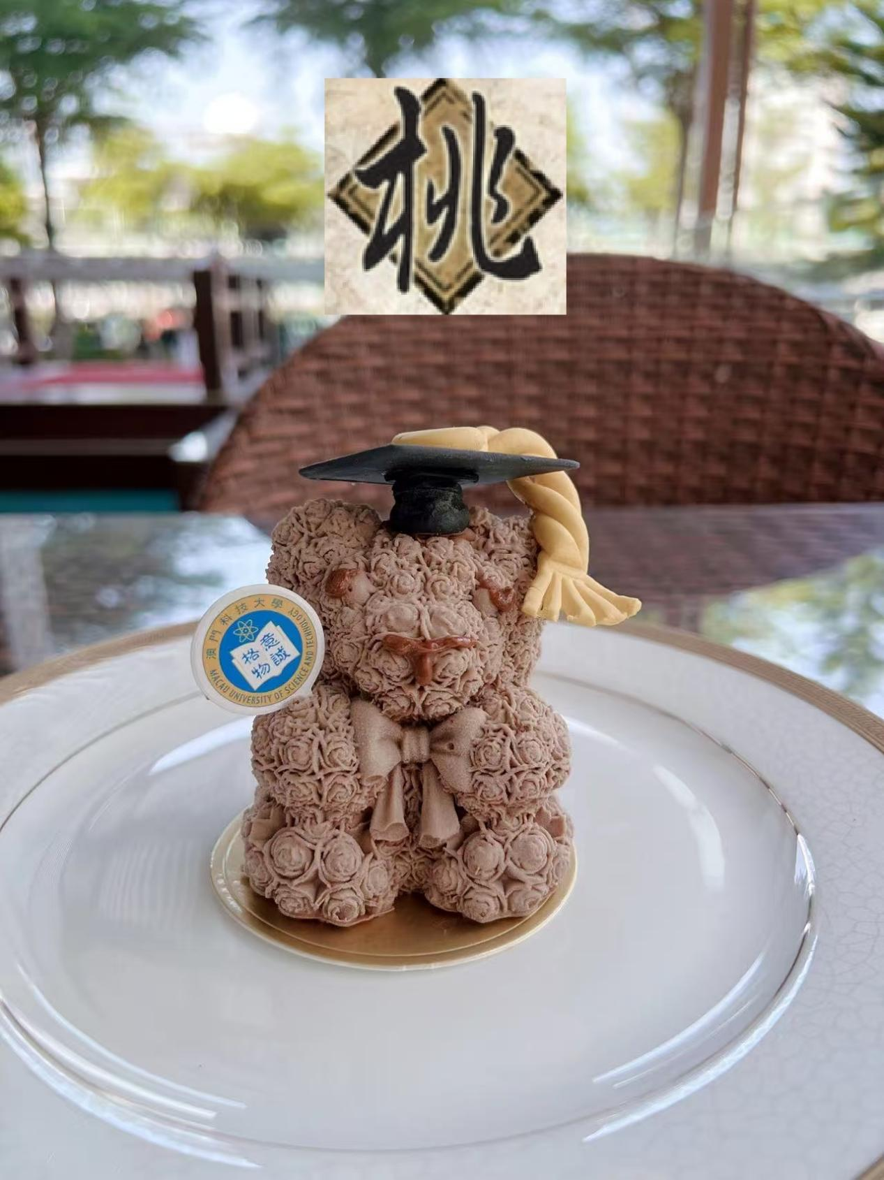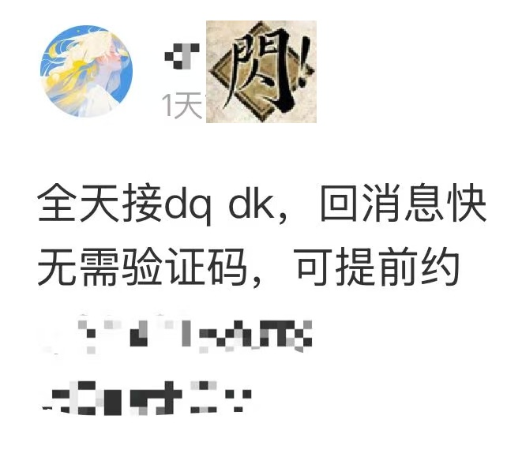

Next is “TAO”, which means Peach, and using this card in the game allows the player to regain one blood. Here we chose the MUST 20th Anniversary cupcakes made by Season （Shout out to Professor ZhangTao, thank you for ordering pizza for us at Season, we know it's expensive, thank you!）due to the fact that cupcakes are delicious can make us happy!

The next basic card is “SHAN”, which is used to resist damage from “SHA”. Here, we still chose “Sign in instead of someone else”, because after signing in, you can “run away”.

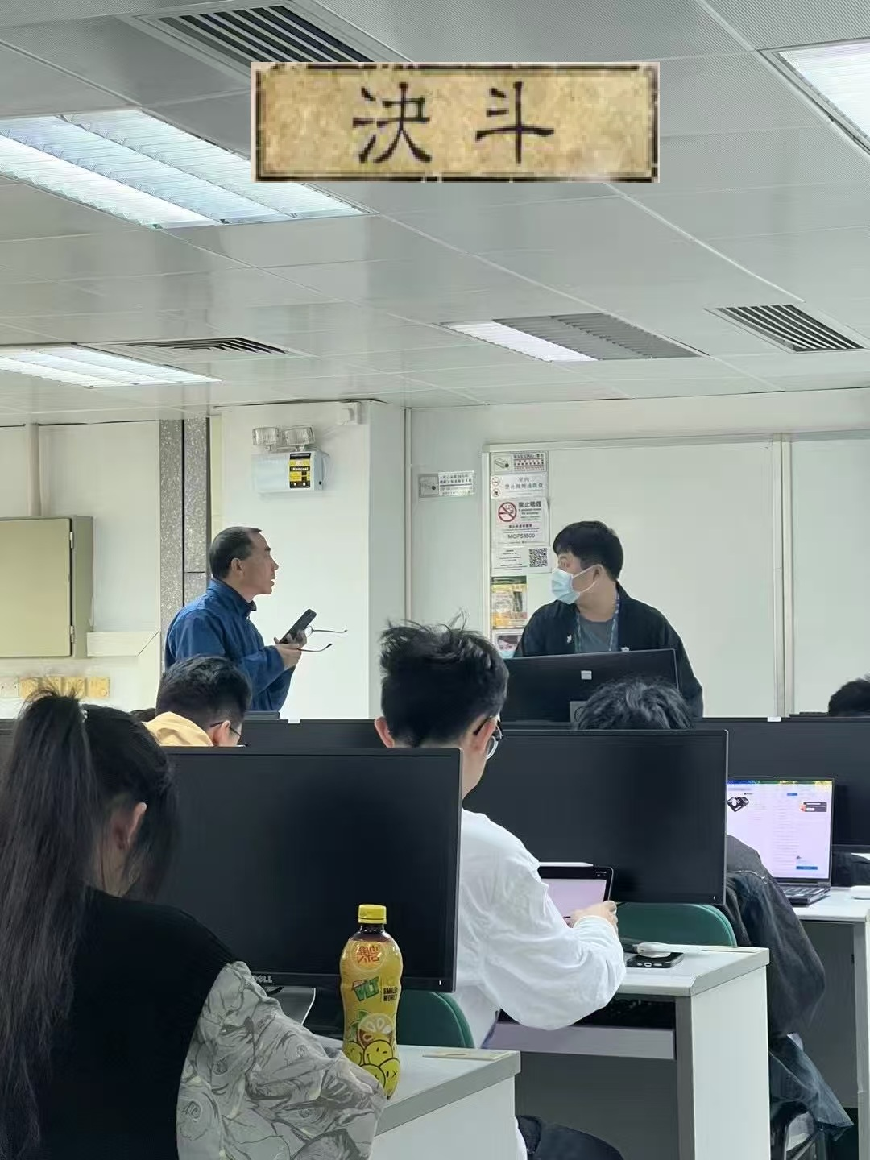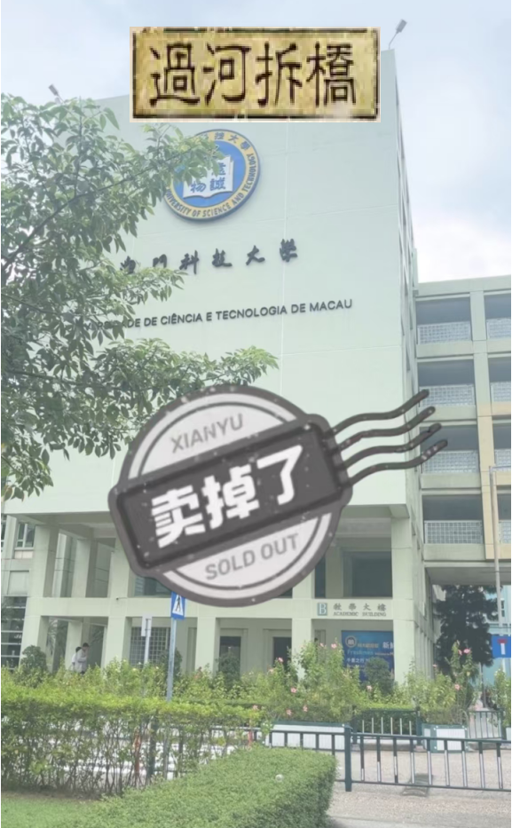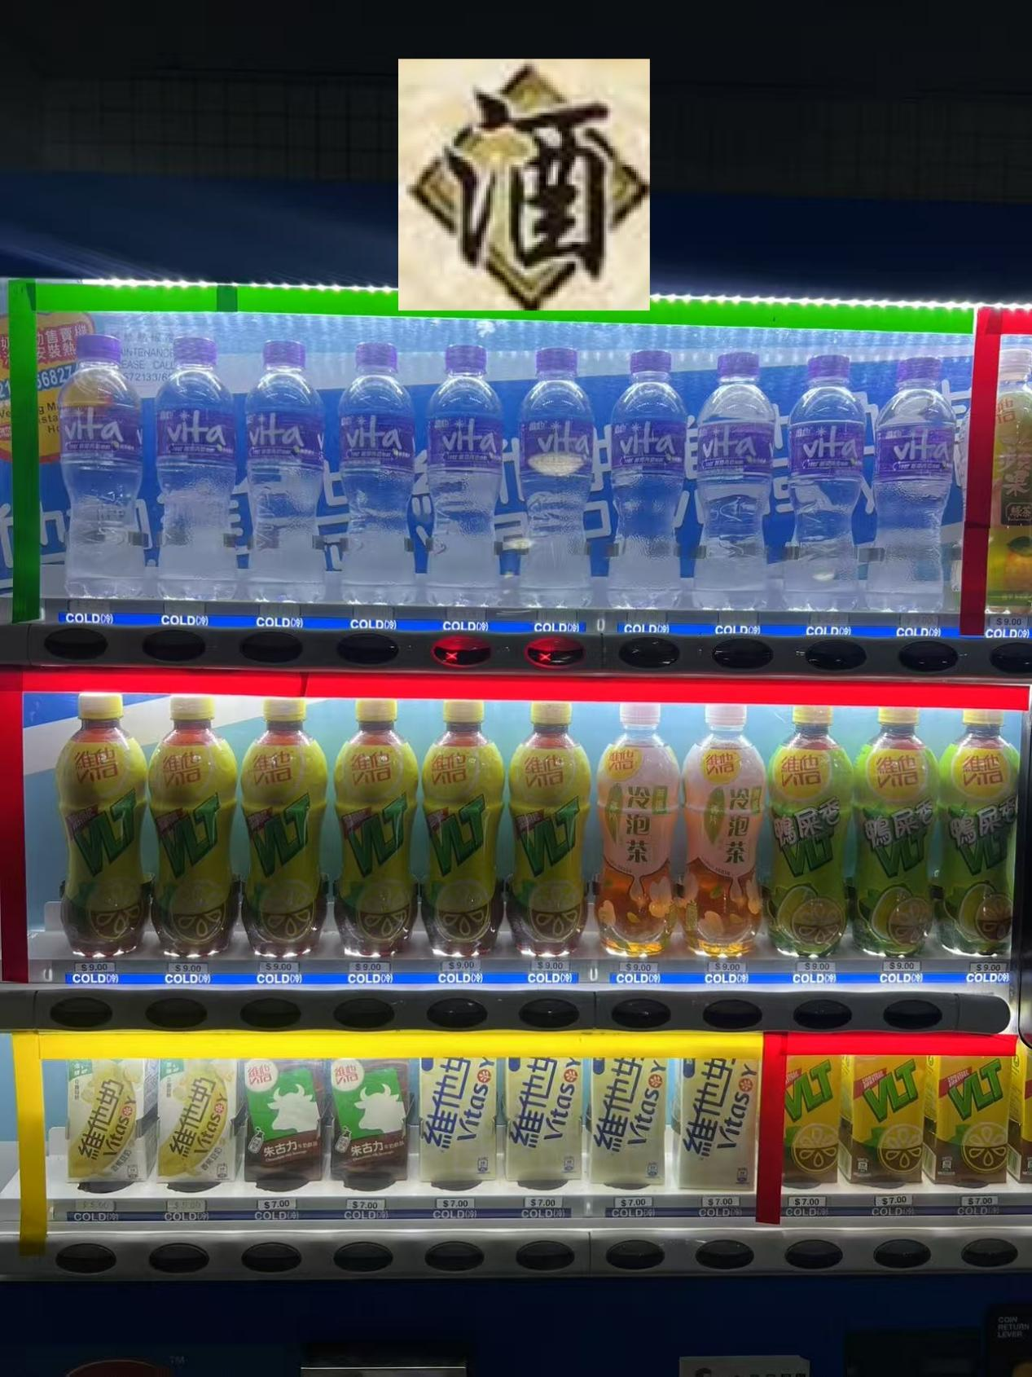

Next is the skill card “JUEDOU”, which means a duel where both players must take turns playing “SHA” until one player has no “SHA” cards, then one drop of blood is deducted.The background of this picture is also interesting, it is the professor Mr. ZhaoQinglin's argument with the faculty due to the broken projector. Both sides argued and finally Prof. Zhao became furious. (Showing respect to Professor Zhao)

The next card is “JIEDAOSHAREN”, which means to kill with another's hand. If the chosen one does not kill the target, one of his equipment will be yours. For this one we chose some images from the Little Red Book. A whole bunch of unscrupulous agents are always comparing MUST to 985, and we think these agents are trying to use MUST as a way to belittle 985.

Next is a skill card “GUOHECHAIQIAO”, which means destroying the bridge after you cross the river to prevent others from crossing. The skill of the card is that you can destroy any card in your opponent's hand (including equipment). For this picture, we chose the scene where MUST is sold on “XIAN YU”. It means we have to sell it after graduation to prevent others from graduating.

The last card is “JIU”, wine. Using this card restores one drop of blood. We chose the most common vending machine in MUST, as buying a bottle of water from a vending machine on a hot summer's day does restore a lot of energy, and it also matches the nature of wine as a fluid. (Most college students are underage and cannot drink alcohol)

These are all the localized elements within our game that we created ourselves. Purely for entertainment, not to be taken seriously, all in an effort to get closer to the lives of MUST students.

## Class-Diagram

In the design of our game, the class diagram shows the core components of the game and how they relate to each other. First of all the Game class is the core of our whole project, the current round and the game state are its properties and it manages the start and end of the game and the start and end of each round as well as checking if it is winning or not. Associated with the Game is the Player, as every Game has a Player, whose attributes are name, blood and cards. So obviously, Player relies on Card, which is why Player and Card are connected by dashed arrows. Since the AI takes over the game, he acts as a normal “human” and does the same actions as a human. So the AI class inherits completely from Player, in short, the AI can do everything Player can do.

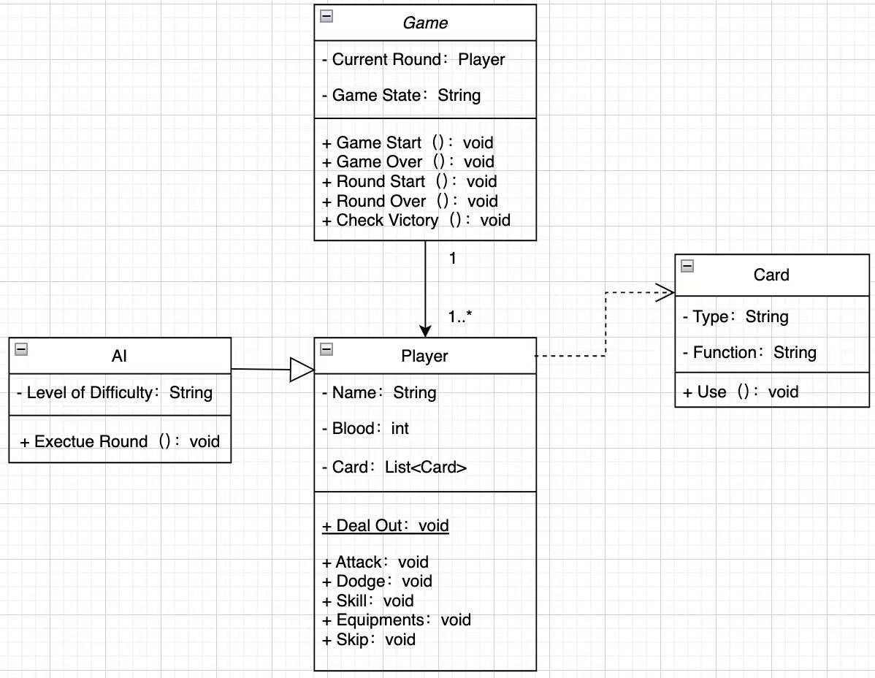

# Agile Development

## Team Structure

**Agile team: All members**

**Scrum Master: Wen Haoyu**

**Software：Leangoo**

## Overview

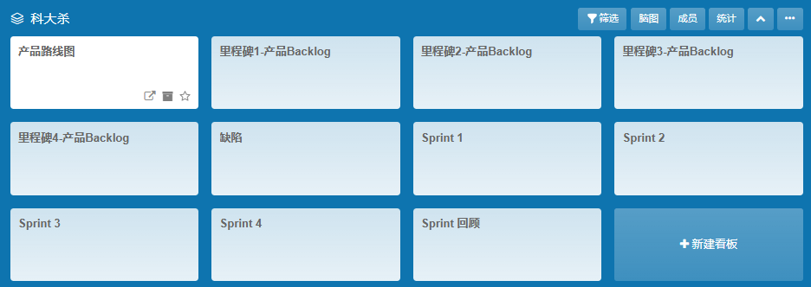

## Product Roadmap

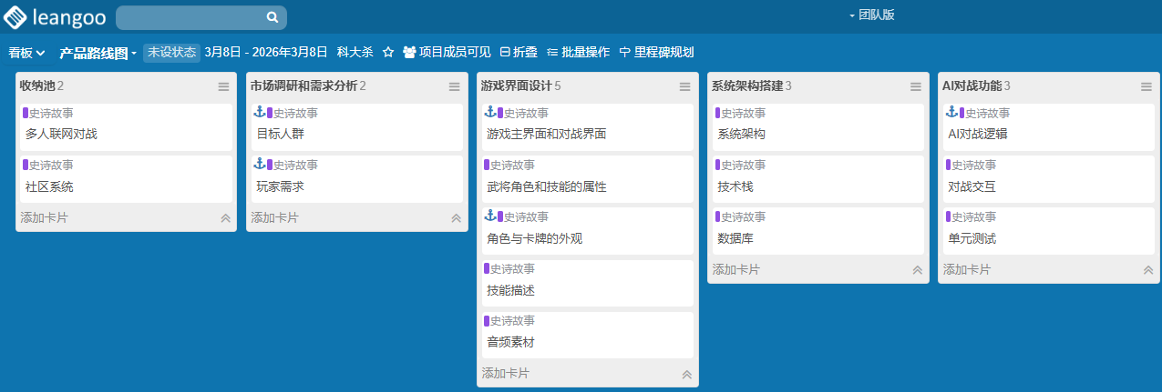

## Milestone

### **Backlog 1**

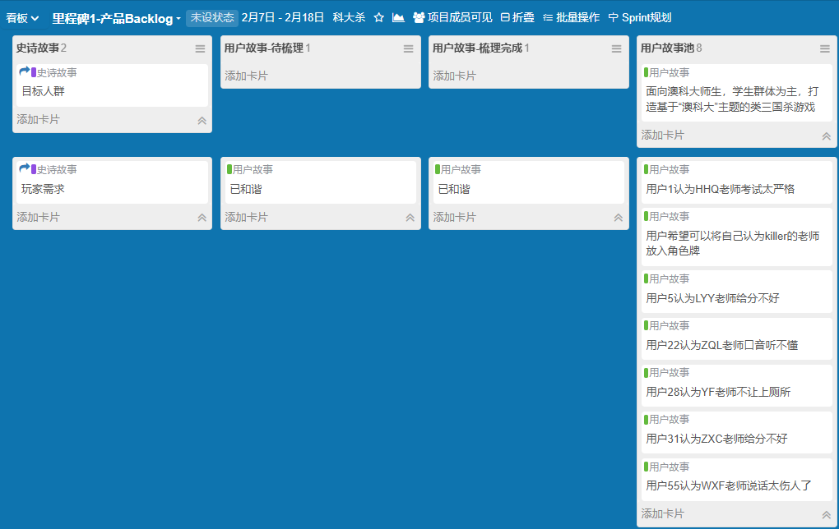

### **Backlog 2**

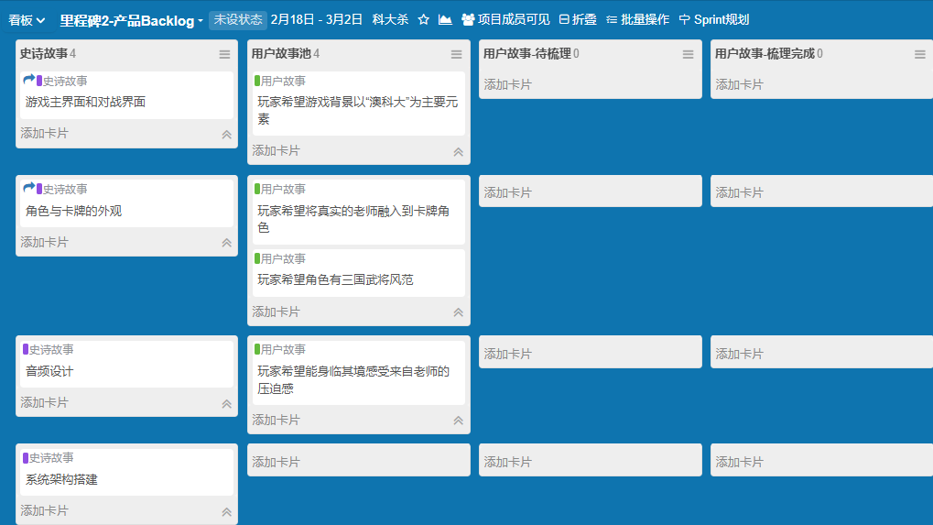

### **Backlog 3**

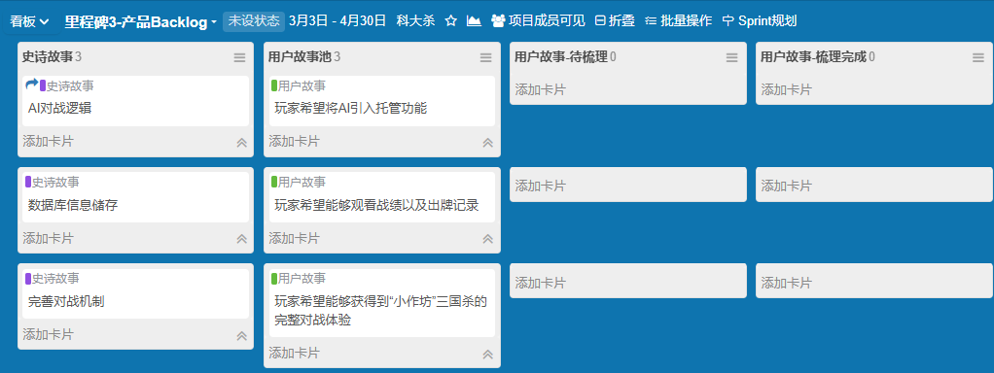

### **Backlog 4**

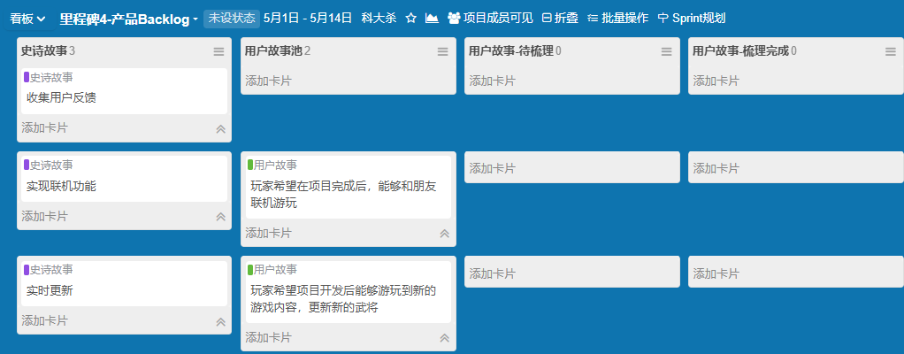

## Defect Record

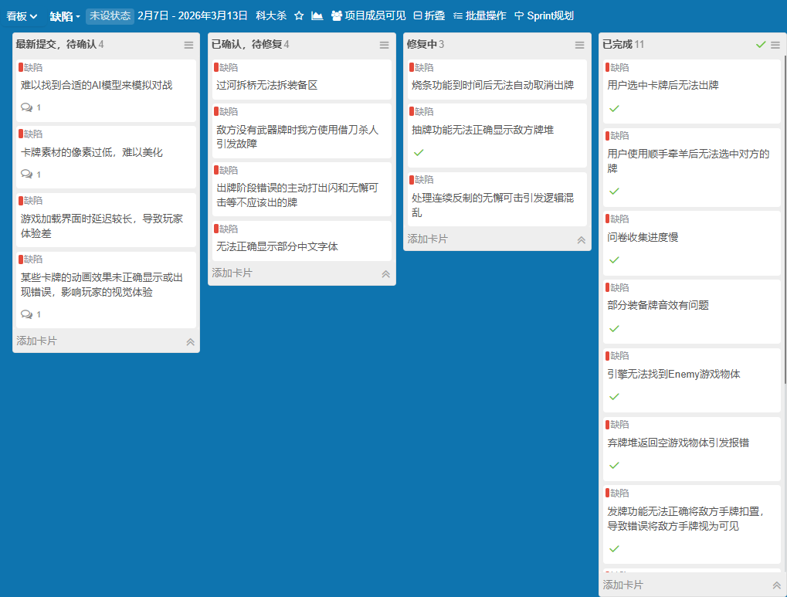

## Sprint

### **Sprint 1 （2.7-2.25）**

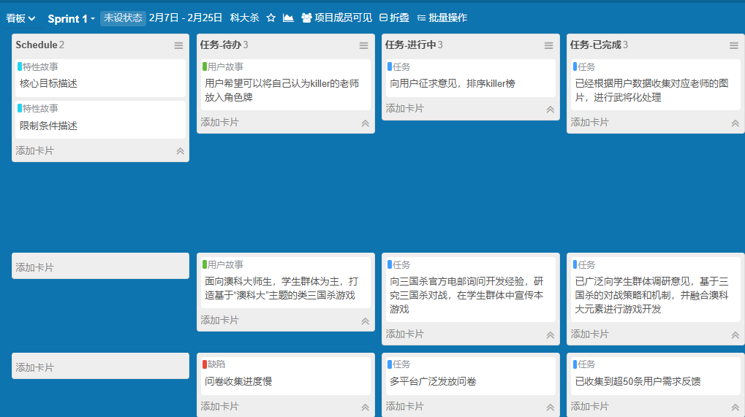

### **Sprint 2 （2.26-3.13）**

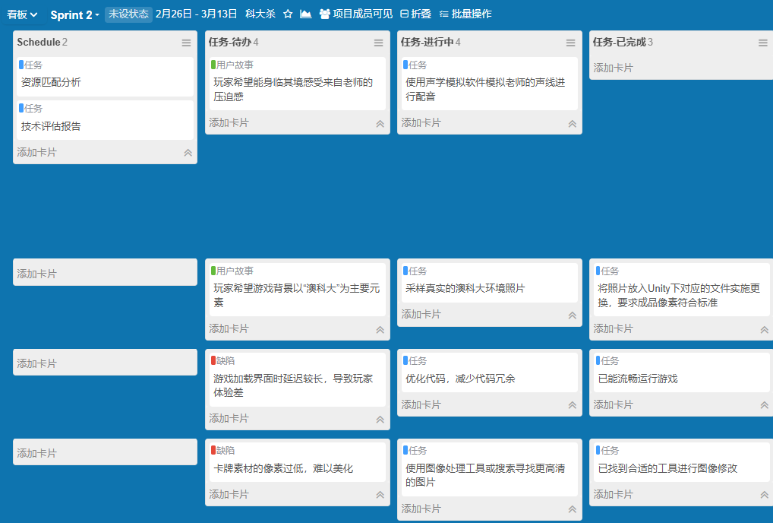

### **Sprint 3 （3.13-4.13）**

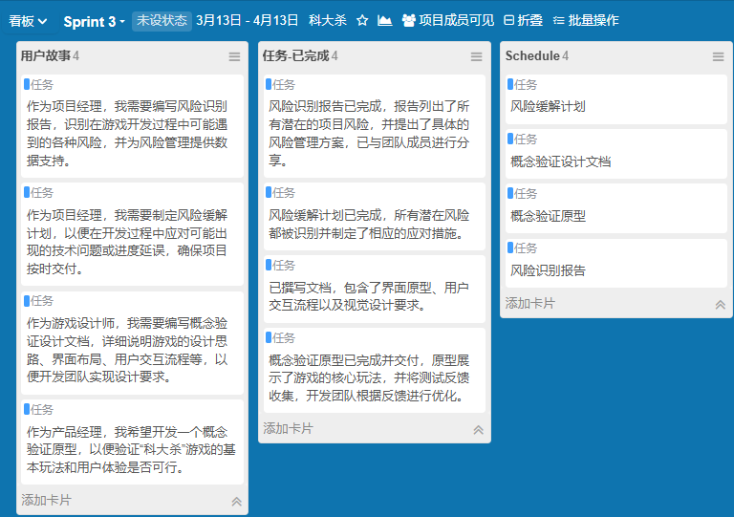

### **Sprint 4 （3.13-4.13）**

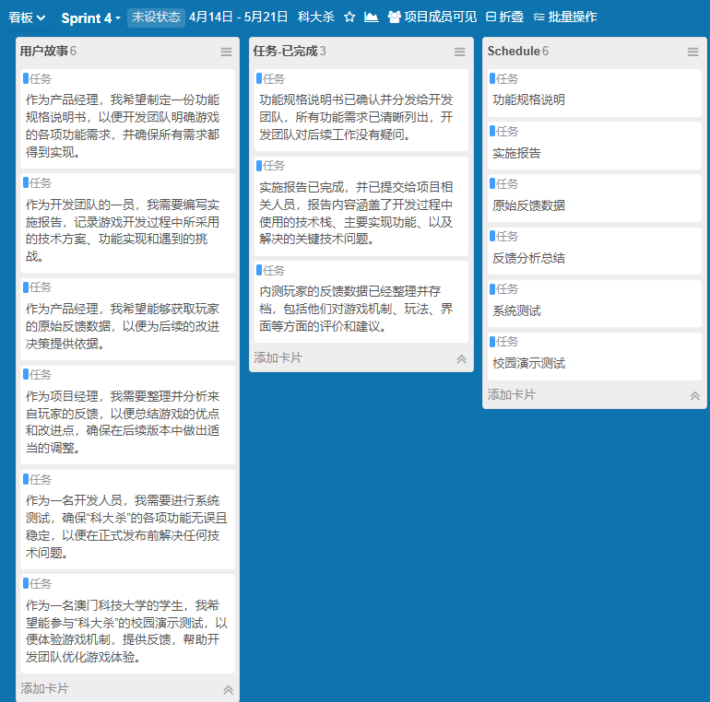

## Sprint Review

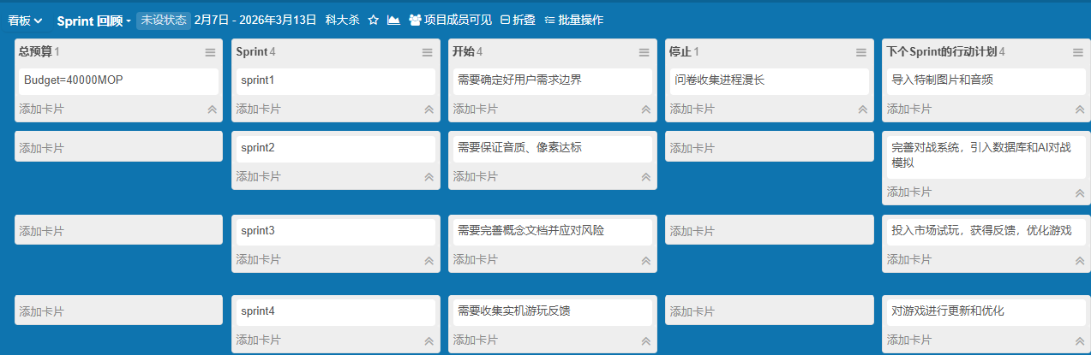

# Budget and Schedule

## Human Resources Cost

Huang Yixing （unity development engineer）salary/month: 4500 Actual：500

Wen Haoyu（project manager document specialist） salary/month: 5000

Actual: 550

Sun Yiran（art designer）salary/month: 3500

Actual: 400

Zhang Haozhan（Audio Engineer, Spreadsheet Designer）salary/month: 3500

Actual: 400

Total:1850

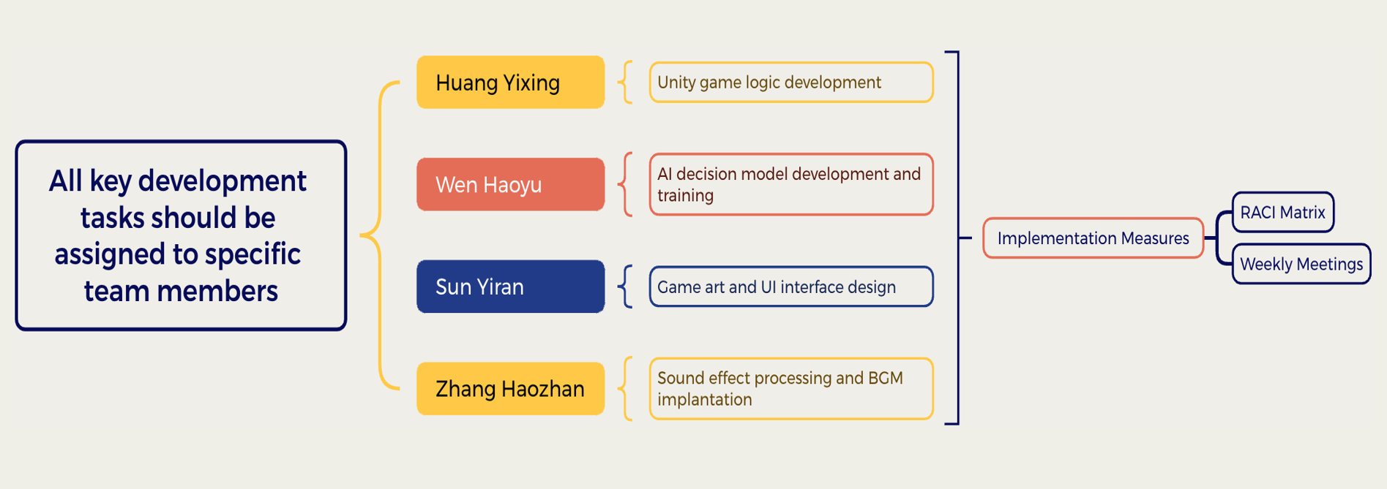

## Development tools and software cost

unity: free

data base (MYSQL): free

audio process tool：free

photo shop（art tool）：7.9/month

total: 7.9*3=23.7

## Hardware resource

development device laptop：500

Server or storage：local, free

## Other

questionnaire and leaflet：10

team building：eat 100

## Schedule milestone week 1-2

Collect feedback from classmates and analyze the market demand. Give the definition of the game features and gameplay then determine design direction and target audience, draft the initial requirements document.

## Schedule milestone week 3-4

Design the interface in main canvas and architecture, finalize character and function of card, process and find import audio materials then complete preliminary sound and visual GUI design.

## Schedule milestone week 5-11

develop the main UI of the game controller and the database. Use C sharp and ensure that the enemy can respond the player’s card and enable the AI of enemy play card logic make sure no bug in the game to keep the experience feeling

## Schedule milestone week 12

launch the game in the campus to students and collect the feedback, then fix the game with the feedbacks to improve it.

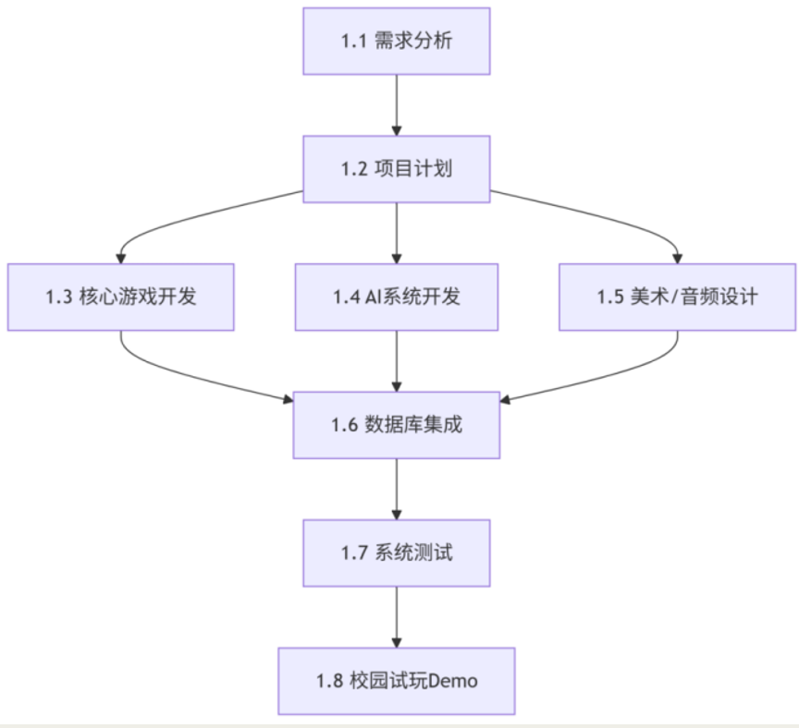

# Software Metrics and Equations

## feasibility check

analysis the tech finance time and resource and based on the software components，development environment and the staffs

## software size estimation（LOC）

AI logic of the Enemy：1200 lines

Game scene：400 lines

Database：1300 line，include the definition of cards，function and splash

Battle logic：2000 lines include the Game controller and sending cards

Total：5100 lines

## Resource Estimation（use case + decomposition）

People resource：This is based on staffs and about their availability，application time，require time and descriptions，list the time spending and effort of every members in the team every week

Reusable software component：software using as the tools of the development of our project，including MySQL，Unity Engine，AI plugins and many art and Audio Softwares

Cost（based on time using and resource investment）：the goal is to save the investment as possible，because it is a

student project

## Metrics of process and projects

function points calculation：list the main function of the game，for example：battle，Enemy ai，history function、selection of player etc

VAF：Evaluation of the factors that may infect in complexity of the game，including GUI、communication of the data，performance requirements，maintainability, environmental change, and deployment platform and so on

CAF：0.65 + (0.01 × 32) = 0.65 + 0.32 = 0.97 (32 is the total score about 14 Value Adjustment Factors)

## Function point Calculation（non adjusted）

including：

* Internal Logical Files (ILF)
* External Interface Files (EIF)
* External Inputs (EI)
* External Outputs (EO)
* External Inquiries (EQ)

The formula：FP = (10 × ILF) + (7 × EIF) + (4 × EI) + (5 × EO) + (4 × EQ)

Add the value：(10 × 4) + (7 × 2) + (4 × 5) + (5 × 2) + (4 × 3)

Final FP：96

## Function point calculation（adjusted）

calculate formula：AFP = FP × CF

adding value：AFP = 96 × 1.26 ≈ 120.96 (Complexity adjustment factor for the mid-term phase is 1.26)

## Use-case oriented metrics

Main test : 10 use cases aimed at testing the function and battle of the game.  
Estimated application size: Number of lines unspecified.  
Testing design: Approximately 10 test cases for every use case, totaling about 100 test cases.

## DRE

**Formula：E₁ / (E₁ + Ei+1) = DRE**

**Ei : the error that discovered in current activity**

**E{i+1} : error discovered in next activity**

**Sprint 1: 10 error**

**Sprint 2：8 error**

**Sprint 3: 12 error**

**Sprint 4 : 4 error**

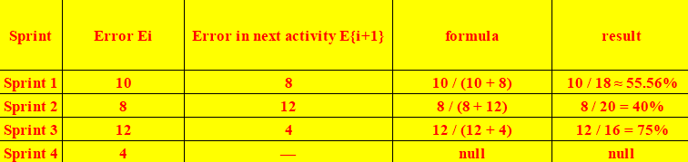

* **Sprint 1**：DRE ≈ 55.56%
* **Sprint 2**：DRE = 40%
* **Sprint 3**：DRE = 75%
* **Sprint 4**：none

# Tracking and Control

## EVA

**BAC （Budge） = 40000 $**

### **Sprint 1**

**EV = 5000 $**

**AC = 2766.34 $**

**CV = 2233.66 $**

**CPI = 1.81**

**Completeness = 12.5%**

### **Sprint 2**

**EV = 15000 $**

**AC = 12500 $**

**CV = 2500 $**

**CPI = 1.2**

**Completeness = 37.5 %**

### **Sprint 3**

**EV = 30000 $**

**AC = 20000 $**

**CV = 10000 $**

**CPI = 1.5**

**Completeness = 75 %**

### **Sprint 4**

**EV = 40000 $**

**AC = 28200 $**

**CV = 11800 $**

**CPI = 1.4**

**Completeness = 100 %**

## Control

### **Scope Validation**

**· Game UI/UX design: whether the interface conforms to the player's habits and is easy to understand.**

**· AI logic test: facing the user, AI can perform operations correctly and will not have abnormal behavior.**

**· Gameplay verification: confirm that the 1v1 rules, mechanisms, and general settings meet expectations and are recognized by users**

### **Scope Control**

**· Demand change management: if it is found during the development process that the health bar design of a (teacher) general does not conform to the character setting, a change application needs to be submitted, and after discussion, it is decided whether to modify it.**

**· Functional scope control: limit the game to only 1v1 AI battles, and do not expand to multiplayer mode to ensure that the project is completed on schedule.**

**· Resource management: ensure that the investment in resources such as art, audio, and AI training does not exceed the planned scope, and mostly use open source free software. If changes are required, the cost record needs to be changed.**

# Risk Management

We use an online MySQL database to manage RIS instead of RMMM documents.

## Visualization Static Interface ( 3‘M’)

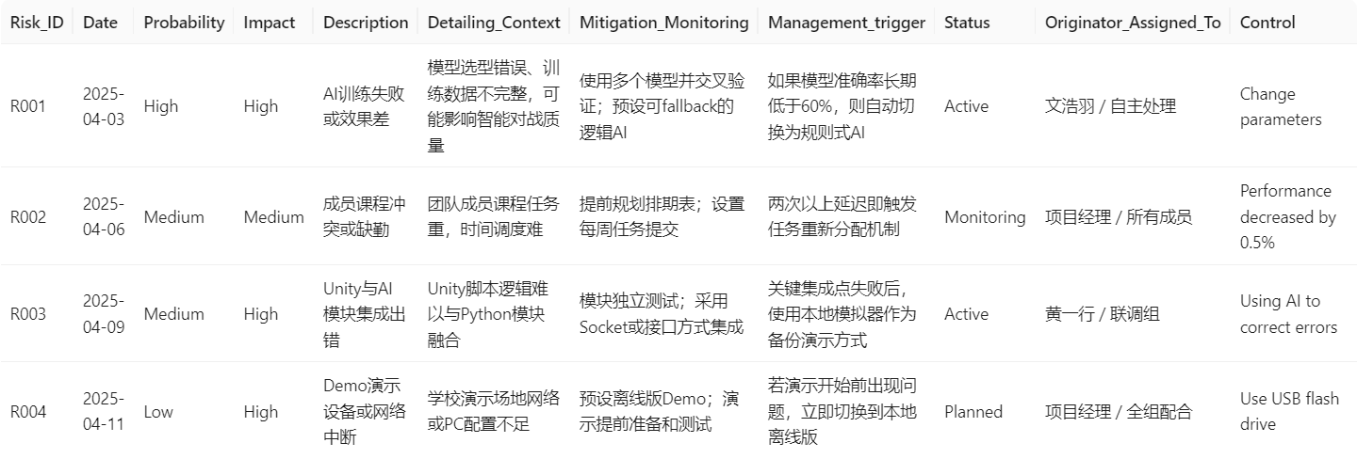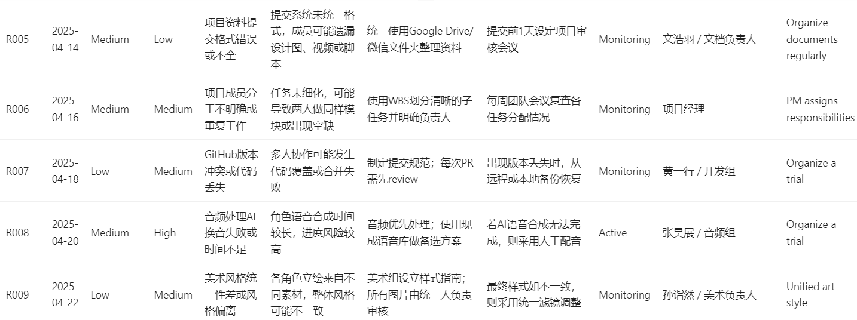

## Database Structure

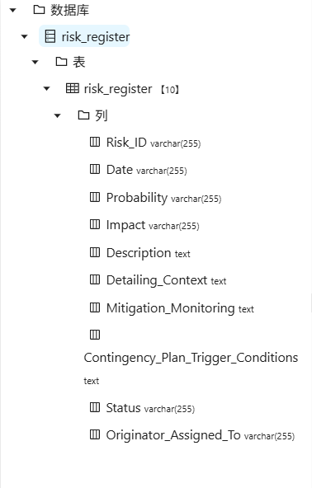

## Pareto 80-20 rule

We focus on identifying and addressing the following “ vital few ” risks :

**·AI model training failure (affecting the core function of the battle)**

**·Member time conflicts or absences (affecting progress)**

**·Unity integration and deployment errors (affecting delivery)**

# Software Quality Assurance

## Functional and performance requirements

### **Functional requirements:**

**·Support players to select generals and demonstrate skills.**

**·Realize 1V1 battles, including core gameplay such as playing cards, judgment, and settlement.**

**·Provide AI functions to achieve basic intelligent battles.**

**·Integrate sound effects and basic animation feedback to enhance the gaming experience.**

### **Performance requirements:**

**·Game response time is controlled within 200ms.**

**·AI decision-making time is controlled within 1 second.**

**·The program runs stably and does not crash for a long time.**

**·Resource consumption is controlled within the range of students' common computer configurations.**

## Documentation of development standards

**·Write a unified code specification.**

**·Use Git to manage the project.**

**·Specify the communication format and interface documentation between Unity and AI.**

**·Each functional module needs to pass unit and integration tests.**

**·All development and testing documents are stored on the shared platform github.**

## Implicit characteristics needed

**·Reliability**

**·Maintainability**

**·Expandability**

**·Security**

**·User-friendliness**

**·Deployability**

## FTR

### **Membership**

**·Moderator：Wen Haoyu**

**·Reader：Sun Yiran , Zhang Haozhan**

**·Recorder：Huang Yixing**

**·Producer: Huang Yixing**

### **Overview**

**First, familiarize group members with our program**

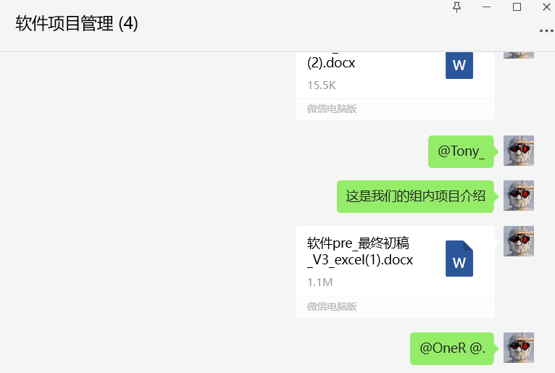

### **Advanced Preparation**

**Provide a copy of the product details to the reviewer (PM from another group)**

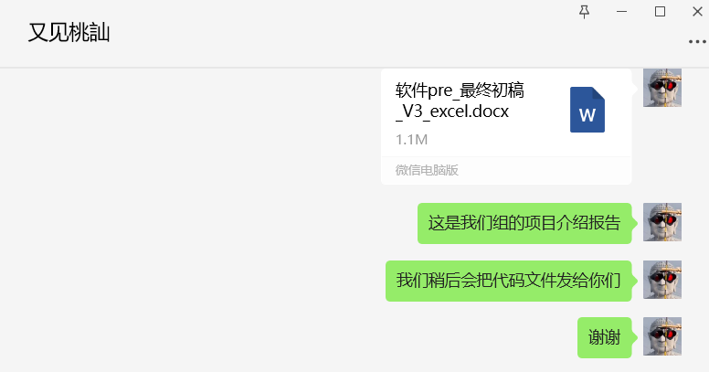

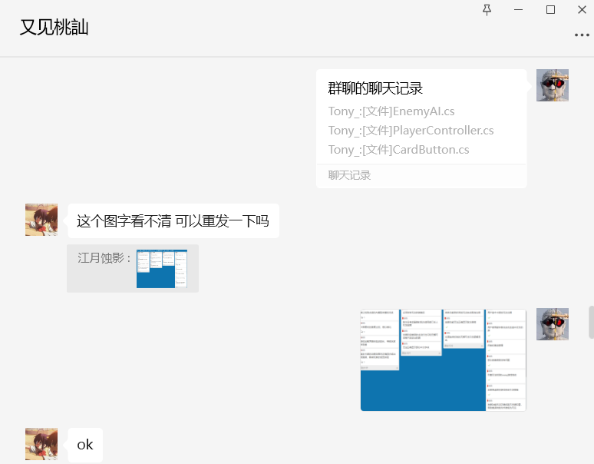

### **Inspection Meeting**

**Reviews were generated through conversations and multiple calls**

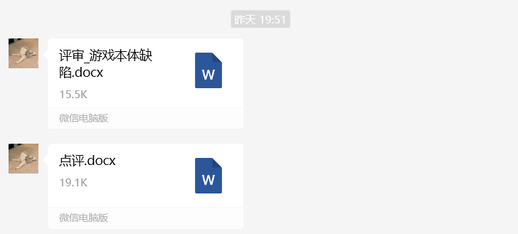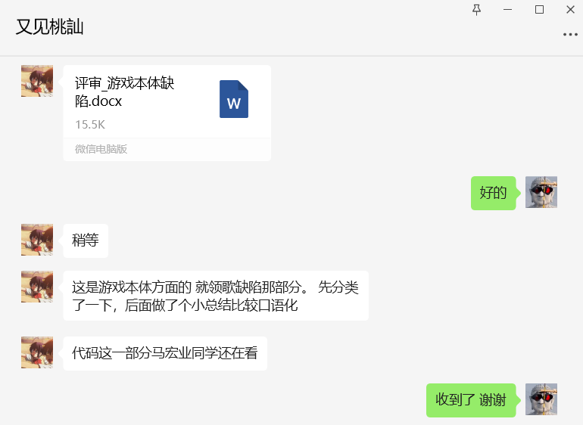

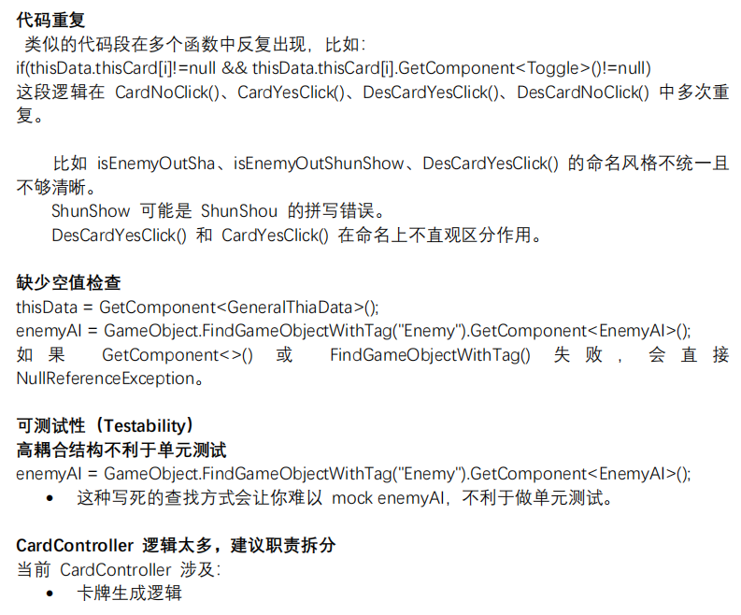

### **Rework**

**Submit review reports to producers for revision**

1

### **Follow up**

**After many revisions and meetings, our program passed the review**

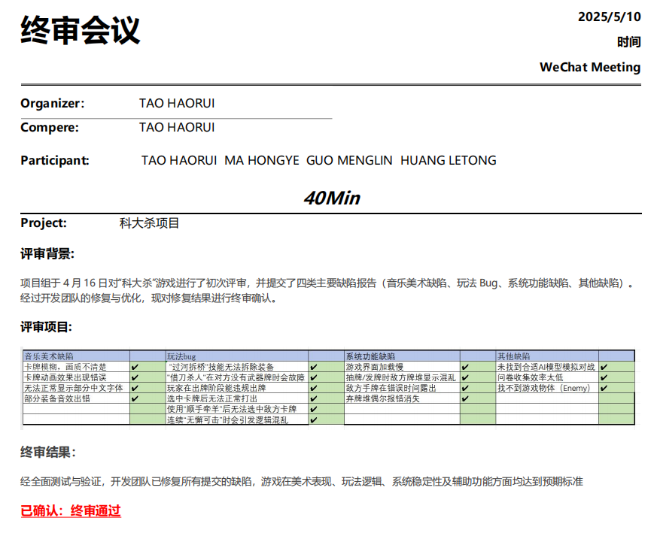

# Software Project Management

## Software Reliability

1. **Definition:**

* **Reliability = 0.95, in each complete game or interaction operation, there is a 95% probability of failure-free operation.**

1. **Relationship of Software Reliability & Failure:**

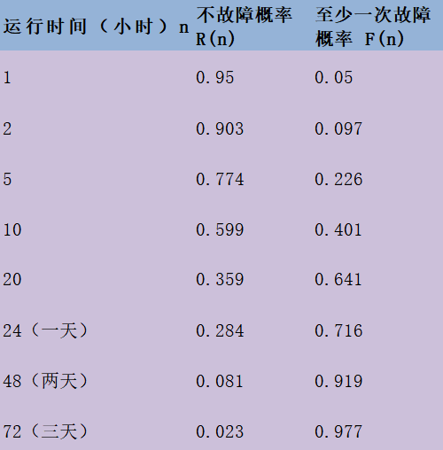

* **F(n) = 1 - R(n)**
* **R(n): the probability of no failure occurring within a specified time period.**
* **F(n): the probability of at least one failure occurring within a specified time period.**
* **We use hours as the basic unit.  
   R(1) = 0.95  
   F(1) = 1 - R(1) = 0.05  
   R(n) = 0.95ⁿ  
  F(n) = 1 - R(n) = 1 - 0.95ⁿ**

1. **Availability = [MTTF / (MTTF + MTTR)] * 100%**

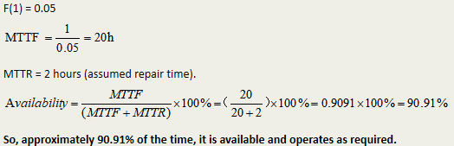

## Software Safety

1. **Definition:**

* **Identify & assess potential hazards that could lead to system failure, focusing on technological risks**

1. **Process**

* **Categorize hazards by criticality and risk**
* **Analyze severity & probability of occurrence**

1. **Key Difference from Reliablility:**

* **Reliability: Statistical analysis of failure likelihood**
* **Safety: Examines how failures create hazardous conditions**

## Quality Standard

* **ISO 9001:2000: Specifies 20 requirements for quality management systems.**
* **ISO 9000-3: Guidelines for adapting ISO 9000 to software development processes.**
* **Certification: Requires third-party audits for compliance, with semiannual surveillance reviews.**

## CMM Model

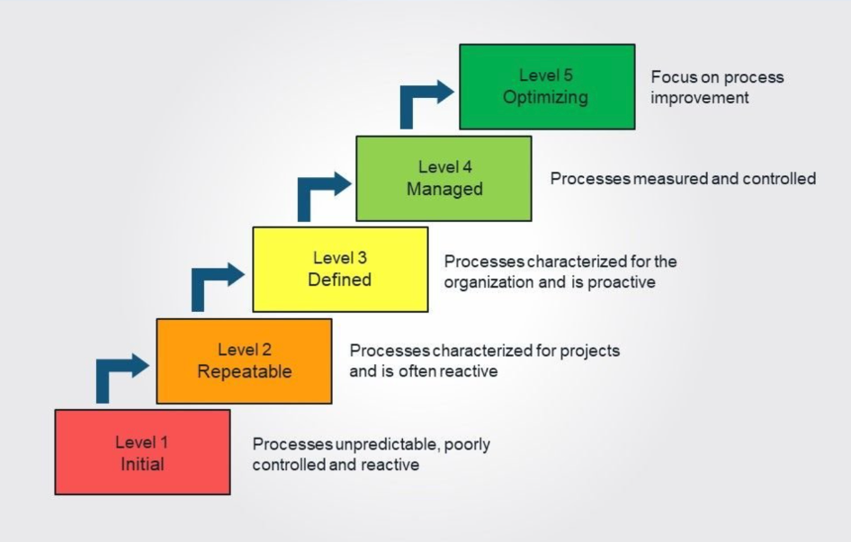

1. **Our team adheres to CMM instead of CMMI, and we are at Level 2 - Repeatable:**

* **We focus on the standardization and improvement of software development and process management, which aligns with the goals of CMM.**
* **There are no requirements for multi - domain integration. We concentrate on a single domain, namely game software development, without any in - depth integration across multiple domains.**

1. **CMM Level**

* **INITIAL: The team has already carried out certain process management and documentation work.**
* **Repeatable: The team possesses certain project management capabilities. Clear management processes have been established in aspects such as resource and cost estimation, communication methods, and project charters, enabling the replication of successful project experiences.**
* **Defined: There is a certain degree of process standardization in project documentation, requirements analysis, and resource estimation.**
* **Managed: For example, there is no quantitative management and continuous dynamic optimization of the database, so this level has not been achieved.**
* **In summary, our team's CMM is at Level 3.**

## SCM

1. **SCM Fundamentals**

* **Identifying s/w work products that are likely to change**
* **Establishing relationships among them**
* **Defining mechanisms for managing different versions of these work products**
* **Controlling changes**
* **Auditing and reporting on the changes made**

1. **SCIs & Baselines**

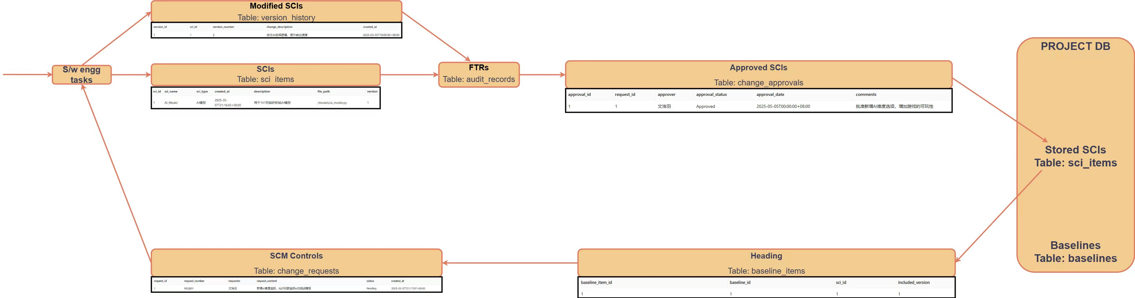

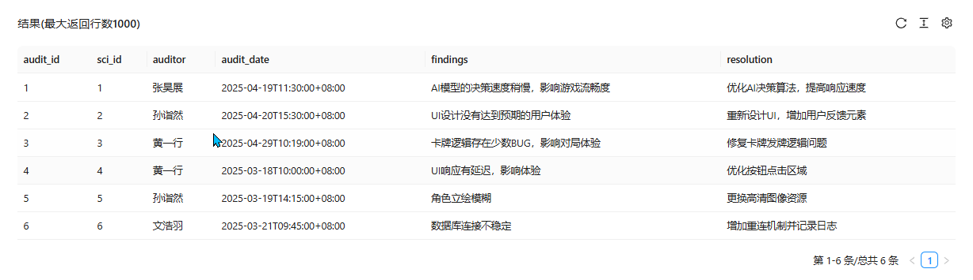

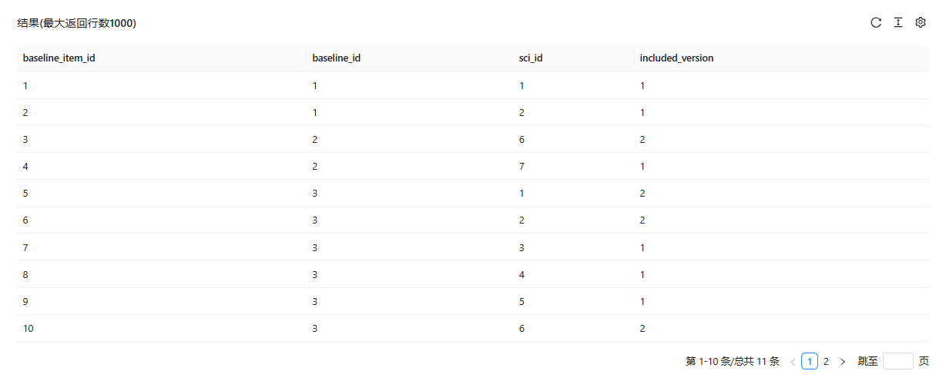

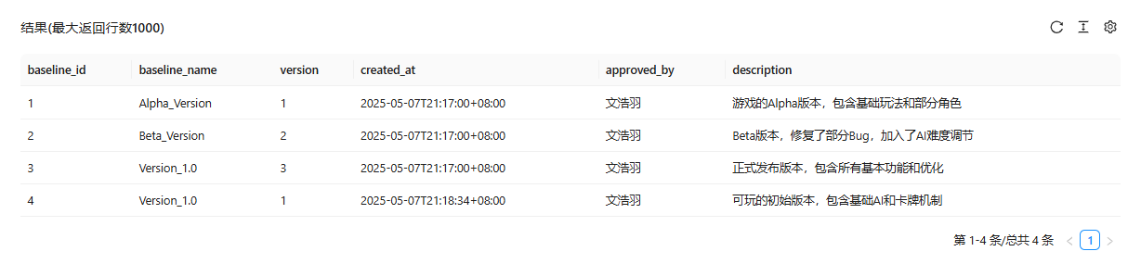

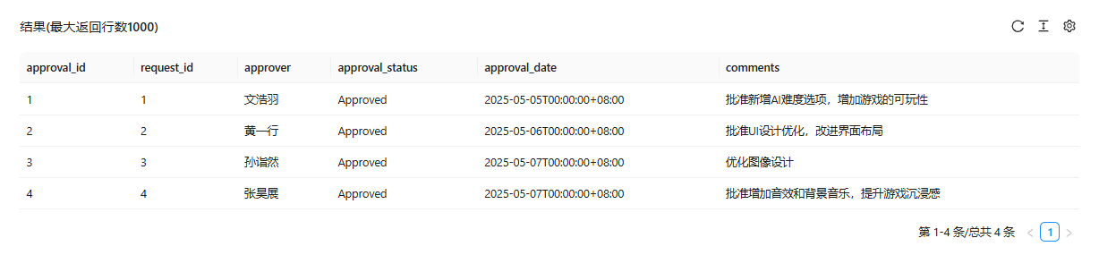



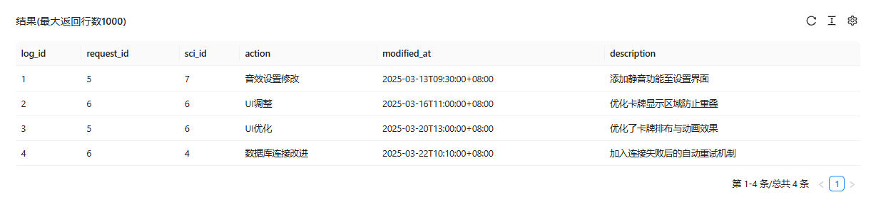

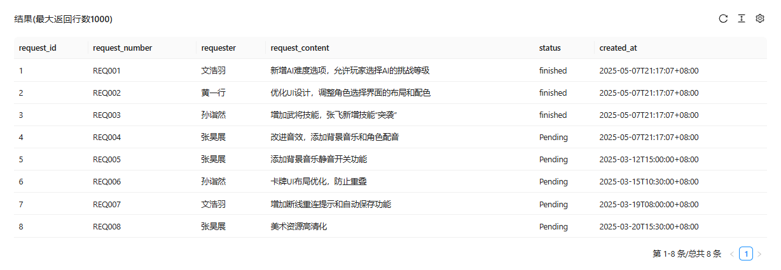

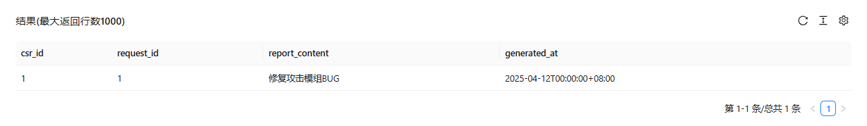

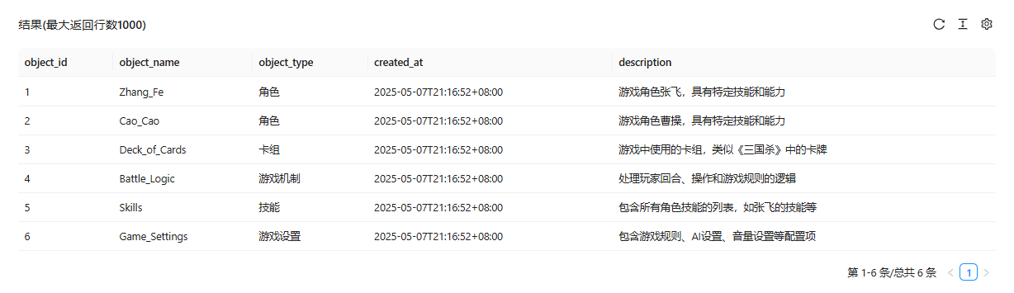

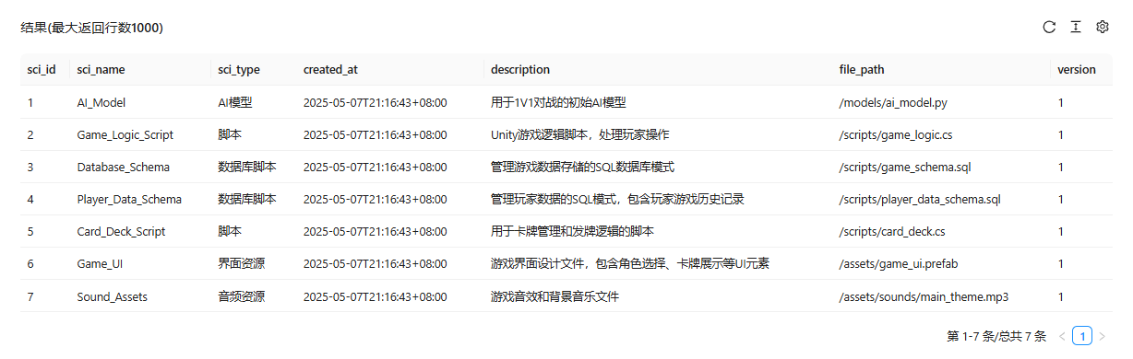

1. **Configuration Objects**

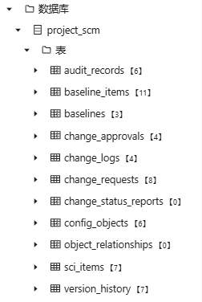

## Version Control

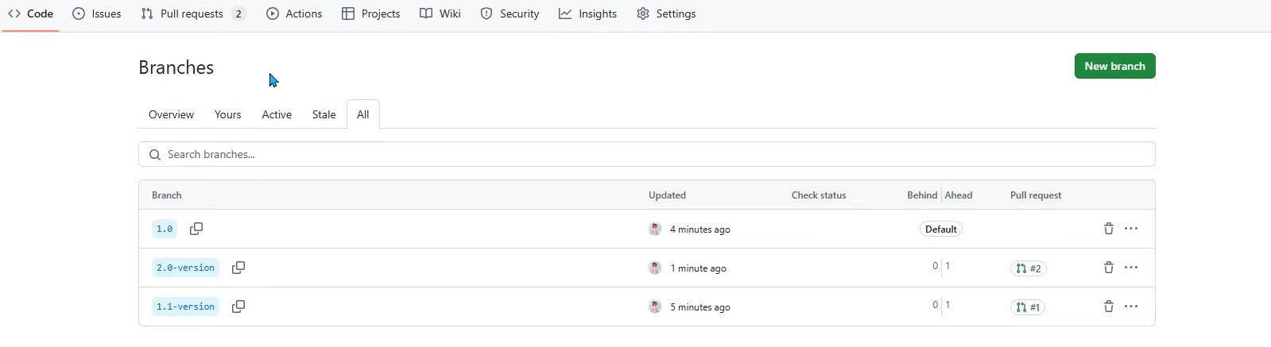

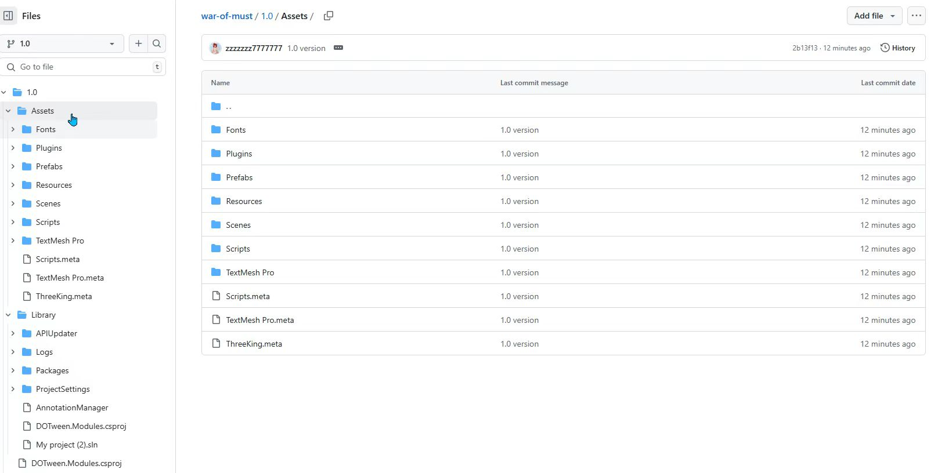

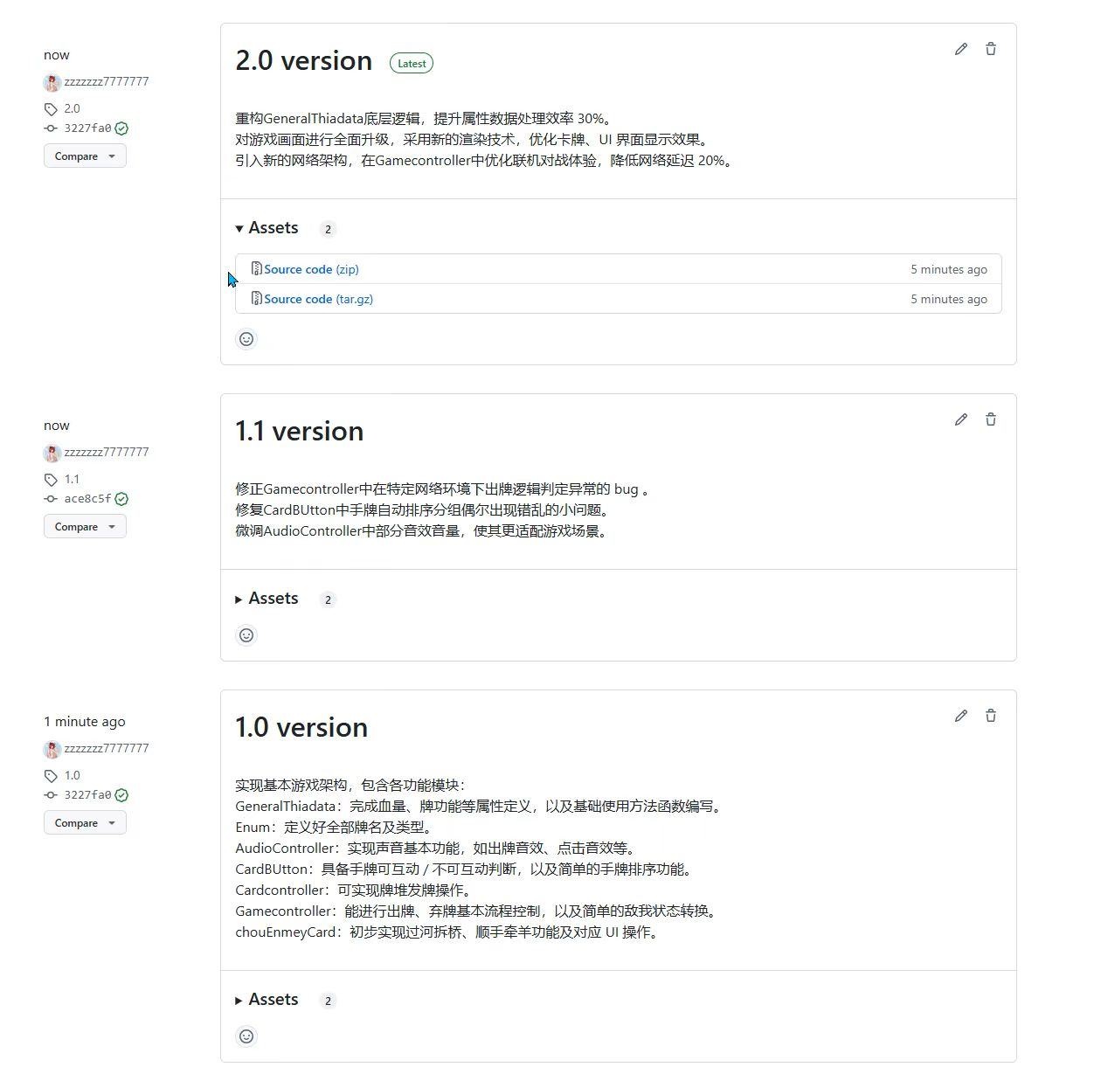

# Software Team Organization and Teams

## Team structure

* **Stakeholders : The MUST students & teachers**
* **Team Leaders ：Wen Haoyu**
* **Software Team ：ALL members**
* **Agile Teams ：ALL members**
* **Software Team Organizations : Controlled decentralized & Hybrid Structures（Type II —— Use hierarchies of organizational structure.）**

## Personality test

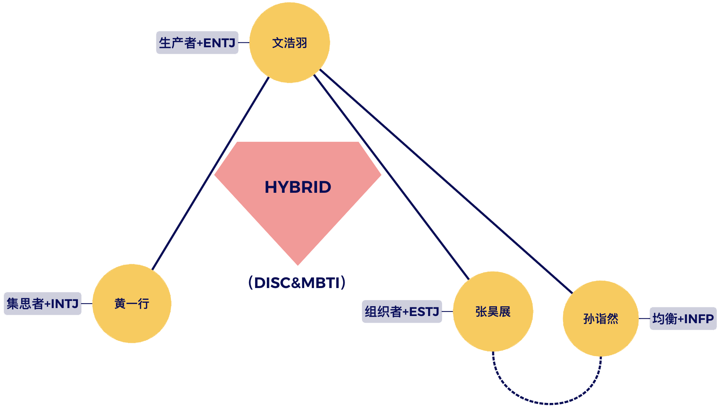

## Contribution-based evaluation

**The total score is 100 points, and we divide this 100 points into 6 weighted parts according to the task content. Divide 100 points into 600 percentage points (600%)**

**Then we evaluate the percentage of each person's contribution for each task content.**

|  |  |  |  |  |
| --- | --- | --- | --- | --- |
| **Task** | **Wen Haoyu** | **Huang Yixing** | **Zhang Haozhan** | **Sun Yiran** |
| **Code Contribution** | **20%** | **70%** | **5%** | **5%** |
| **Documentation Work** | **30%** | **10%** | **30%** | **30%** |
| **Presentation and Communication** | **42.5%** | **21.5%** | **18%** | **18%** |
| **Design and Creativity** | **10%** | **20%** | **40%** | **30%** |
| **Project Management** | **20%** | **20%** | **30%** | **30%** |
| **Collaboration and Teamwork** | **30%** | **10%** | **25%** | **35%** |

**Wen Haoyu = 100*(20%+30%+42.5%+10%+20%+30%)/600%** = **25.42**

**Huang Yixing = 100*(70%+10%+21.5%+20%+20%+10%)/600%** = **25.25**

**Sun Yiran = 100*(5%+30%+18%+40%+30%+25%)/600%** = **24.67**

**Zhang Haozhan = 100*(5%+30%+18%+30%+30%+35%)/600%** = **24.67**

# **Course Reflection, Practices, and Comments**

## Wen Haoyu (Project Manager)

At the beginning of the project, we first determined that we all wanted to make a game, because our team members all love to play games. Then a classmate in our group who particularly loves to play Three Kingdoms proposed to make a game similar to Three Kingdoms, so we determined our theme: The Must Kill.

First, we determined that we would use Unity for development, because it is a game engine with high compatibility and a lot of tools, and divided our group into Leader, copywriting group and code development group. The copywriting group is responsible for almost all speeches, copywriting and material compilation, and the code development group is responsible for almost all game development work

During the project development process, each team member cooperated very well. We worked like a company team. Even if some individual team members occasionally delayed the progress due to busyness, we reserved enough time to deal with these crises

Finally, our team achieved the development goal of our game ‘The Must Kill’. After being evaluated by other teams, we successfully demonstrated our game, allowing players to enjoy the Macau University of Science and Technology version of the Three Kingdoms game and smile knowingly after seeing our wonderful design.

In this software development project manager, as a project manager, I deeply felt the difficulty of coordinating and scheduling tasks, as well as the importance of extracting customer needs from the vast text. How to convert the oral or document requirements of customers (teachers) into the tasks we need to complete, and convey and distribute the tasks to team members immediately, and generate a product that can attract customers or satisfy customers within a limited time is what I think is the key task of the project manager.

My team members are very cooperative, brave to overcome difficult tasks, and actively complete tasks, so after calculation, the proportion in the final Contribution base is almost the same, because we are a team, and each of our members is moving towards a common goal!

## Zhang Haozhan (Copywriting team)

This group project was nothing short of an epic journey! From card design to rule balancing, the four of us had countless discussions. When final testing rolled around, bugs emerged left and right, and we found ourselves still debugging at 3am. But when we finally saw the finished product, that moment made it all worthwhile - though next time we're definitely starting testing much earlier!

## Sun Yiran (Copywriting team)

I have benefited a lot from the software project management class I took this semester. We not only learned a lot of theoretical knowledge such as agile development, waterfall model, project lifecycle and DRE, etc., but also the teacher gave us the opportunity to practice. Formally the teacher gave us the opportunity, let us four students who know nothing to form our first project in a decent manner, and finally in our unremitting efforts and under the bonding, we also created a more satisfactory and MUST color “MUST KILLING” game. We would like to thank our teacher for providing us with the opportunity to practice.

During the group practice, I was mainly responsible for UI design and manuscript writing. It seems to be an easy activity, but in order to get closer to the campus life of MUST, I need to consider the name of each skill, the introduction, and the pictures, so that our project can be the most perfect experience.

I appreciate the teacher's classroom 100%! Not only was there a combination of theory and practice, but the teacher also gave the decision-making power to those of us present during the group marking. This was unprecedented and fair.

I learned a lot through this class, and I think I learned more about teamwork skills than technical ones. Combined with the exploration of multiple Sprints, it fully improved my communication and time management skills.

In the end, I would like to thank Professor Zhang again, I have learned a lot in your class, and I hope I can take your class again in the future!

## Huang Yixing (Code writing team)

In the class, I’ve learned many knowledge about how to create and how to operate a project, which is very useful for my future work in company.

Working with friends is also a fantastic experience of solving and discovering problems, fulfilling with difficulty and challenges. Learning how to use Unity engine from zero to master is quite fun and achievement

By the way, it’s my first time to write thousand of codes independently, and my coding skill have been improved quickly

thanks to dear professor to give me and my friends a chance to exercise our team working ability, and I really enjoy your class!